**CV IP SCHEEPERS**

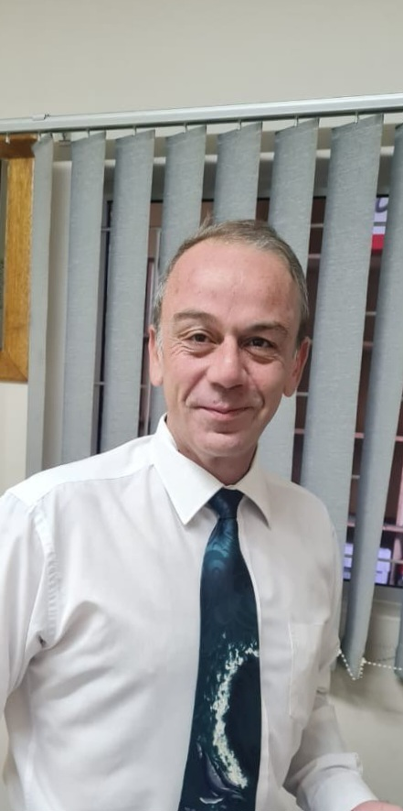

First Names  **IGNATIUS PETRUS**

Surname **SCHEEPERS**

ID Number 750702 5213 080

Email: [ipscheepers@gmail.com](mailto:ipscheepers@gmail.com)

Contact number: 067 875 9411/079 128 2976

Address: 15 Tecoma Avenue, Kariega

Reliable, dedicated, motivated and skilled individual, recently retrenched, seeking permanent position.

Experienced and skilled as an efficientbusiness owner, with managerial, financial and life experience competent to lead and train teams. Code 8 licence holderentailing own transport,seeking for employment within a corporate culture where ethical sound morals, good lines of communication and strong people skills are visibly practiced.

I see myself as a team player and independent self-starter, able to manage groups and individuals on a personal and professional level by motivatingand enablingpeers to add value and build confidence, irrespective of challenges, background and ethnicity.

My ability to be impartial reasonable and fair stems from insight and sound principles evolved and acquired as a legal professional and litigant in Labour, Civil and Criminal Courts throughout the country.

I am multilingual, emotionally equipped to solve problems of any level of difficulty and intend to do so by adding value through a dignified approach. For a unique approach I am willing to make an effort to make a lifetime commitment, if invited to do so.

|  |
| --- |
| **EDUCATION SECONDARY** |
| Name of School **ANDREW RABIE PORT ELIZABETH** |
| Highest Grade Grade12 Exemption |
| Year Completed 1993 |
| Subjects Passed English Fist Language HG, Afrikaans First Language HG, |
| Biology HG, History HG, Mathematics SG; Accounting HG |
| Sports / Activities Tennis, Chess, Rugby, Athletics |
| Leadership Roles Head Boy 1993, Junior Prefect 1992 |
| Associations EP Chess Team // PE Chess Club // Stella Londt Squash Club |
| Achievements Honorary Roll  EP Colours |
| **EDUCATION TERTIARY** |
| **University / College UNIVERSITY OF PORT ELIZABETH** |
| Year 1994 until 2000 |
| Part-time / Full-time BaccalauriusCommerci |
| Degree **B Comm** |
| Major subjects Business and Financial Management |
| **University / College NELSON MANDELA METROPOLITAN UNIVERSITY PORT ELIZABETH** |
| Year 2007 until 2009 |
| Part-time / Full-time BaccalauriusLegum |
| Degree / Diploma **LLB** |
| Major Subjects Intellectual Property& IT Law, Labour Law, Private Law |

|  |
| --- |
| **College DAMELIN**  City Correspondence  Year 2000 – 2001 Part-time  Degree / Diploma CERTIFICATE IN BANKING whilst employed by FNB  Subjects Passed Commercial Banking & Marketing |
| **FURTHER LEARNING & ACHIEVEMENTS**  ADDITIONAL COURSES / TRAINING  MARKINOR Marketing 2000  Admission Exams Cape Law Society 2009  LEAD/PRACTICAL LEGAL TRAINING Cape Law Society 2009  LEAD/PRACTICE MANAGEMENT Law Society of South Africa 2010  AULAI qualification as Debt Counsellor University of Pretoria 2010  Litigation Course Black Lawyers Association 2011  TEFL 2023  **INNITIATIVES & SELF DEVELOPMENT**  Events administration during covid 19 vaccination outbreak Mediclinic Pharmacies 2021  Practical and theoretical mechanical skills advancement K -Parts Hyundai/Kia 2022  Various Webinars & Internet based enrichment projects LESSING HEYNS 2023 |
| **EMPLOYMENT HISTORY** |
| Name of Company **LESSING HEYNS & VAN DER BANK** |
| City / Town KARIEGA |
| Position OFFICE MANAGER & DEBT COLLECTIONS |
| Time Line September 2022 - Current |
| Average Salary R20k per month Plus Commission |
| Duties and responsibilities:  **1. OFFICE MANAGER:**  ***DRAFTING PROCEDURES AND PROCESSES*:** Tasked to write procedures ranging from finance to maintenance in order for protocol to be implemented. A rule can only be broken if it is known. Inter alia:  ***Generator and vehicle fleet management:*** Scheduling diaries for drivers, planning effective routes and petrol requisitions. Overseeing maintenance, upkeep and repairs and servicing, inspections and liaison with insurance when needed. Obtaining quotes and choosing service providers. Presenting options to top Management for approval.  ***General ground maintenance and housekeeping:***Maintaining cleanliness and tidy grounds, at both PE and Kariega Branches. Budgeting for and expediting improvements to security (cameras and armed response), evacuation procedures, codes and accountability of company property. Obtaining quotes and approvals for repairs and maintenance projects for repairing and improving immovable property. Overseeing installations and after sale service.  ***Human Resources****:* Signing off leave and managing workstations for employees. Disciplinary action, emotional and work-related employee counselling problem solving assistance.  *Statutory compliance procedures*:BEE and POPIA and Law Society, Banking Act, ECTA, Magistrate’s Court Act Compliance regulation adherence. Overseeing Sheriff’s accounts. Ensuring prompt payments in collaboration with bookkeeper. Resolving discrepancies and disputes. Attending to Municipal disputes.  ***Rental agent:*** Drafting and regulating existing rental agreements, complaints and transfers. Evictions, non-compliances and acting as intermediary to amicably resolve disputes and evictions.  *Branding:* Causing of redesigning of letterhead, business cards and professional folders, advertisements and sponsoring initiatives.  ***Office Automation:*** Creating clear workable alternatives with competent service providers and liaison to ensure competent long-term solutions with contractual certainty. Internet, telecom, printing and other service providers.  **2. COLLECTION DEPARTMENT HEAD**  The main duty fulfilled in this department entailed an implementation of a feasibility study on collectable debts, making settlements possible and creating procedures for proper billing strategies and query handling with public entities, specifically at the local Kariega Court and the Sheriff.  The lines of authority within the employee’s structures made this a daunting exercise.  The bookkeeper refrained from making available information to effectively manage the department.  At most, in the absence of the information to my avail, I implemented procedures based on the guidelines of the Debt Collections Act to facilitate dignified collection ethics and long-term longevity and rational application guidelines to my employer, as far as the rule of law is concerned.  Settlements and queries were resolved by authorisation of a dedicated director. |
| Name of Company **SCHEEPERS ATTORNEYS & LEGAL ADVISOR** |
| City / Town PORT ELIZABETH |
| Position SOLE PROPRIETOR (Self Employed) |
| Time Line 2012 - 2020 |
| Average Salary R40k (variable) per month |
| Duties and responsibilities: General Entrepreneur |
| Name of Company **DTS ATTORNEYS** |
| Position Litigation Attorney |
| Time Line February – May 2017 |
| Duties and responsibilities:Litigation Attorney |
| Name of Company **DALEEN VAN DER WESTHUIZEN ATTORNEYS** |
| City / Town KLERKSDORP |
| Position PERSONAL ASSISTANT |
| Start Date 2010 - 2012 |
| Salary R12k per month |
| Name of Company **NELSON MANDELA METROPOLITAN UNIVERSITY LAW CLINIC** |
| City / Town PORT ELIZABETH |
| Position CONTRACT OF ARTICLES |
| Time Line July 2008 – September 2009 |
| Salary R6.5k per month |
| Duties: Community service in completing Articles; Drafting of Municipal By Laws. Client focussed liaison in advisory capacity; Team based litigation and tutoring of students. |
| Reason for Leaving Fixed term contract of service in completion of contract of articles |
| Name of Company **QUEST FLEXIBLE STAFFING SOLUTIONS** |
| City / Town PORT ELIZABETH & CENTURION |
| Position Teller and Front of House Floor Manager - Banking Industry |
| Time line 2006 – 2008 Part Time & whilst job hunting 2001 |
| Salary R40 - R50 p/h |
| Duties Floor Manager for through agency at FNB a division of First Rand Bank Limited; Teller; Addressing complaints and queries interpersonally and electronically |
| Name of Company **BOVEY CASTLE** |
| City / Town MORETON HAMPSTEAD (ENGLAND) |
| Position Porter, Front of Hose assistant, Relations and Events |
| Start Date 2004 - 2007 |
| Salary 6£ per hour & Commission |
| Duties in Hospitality Industry: Escorting clientele to rooms and ensuring quality of specified needs and wants; Taking bookings/ Room Inspections; Chauffeuring clients to restaurants and holiday sites; Assisting events in Golf Club-House and Chalets; Assisting as bartender from time to time; Sommelier and Cigar Bar duties from time to time; Running front as house as host from time to time. |
| Reason for Leaving Working Holiday 2004 – 2007 |
| Name of Company **SHOE CITY PTY LTD** |
| City / Town Pretoria/Tshwane Gauteng |
| Position Branch Manager – Kollonade and Centurion |
| Start Date January 2002 until December 2003 |
| Salary R8k per month |
| Duties Attending to cash up of Tellers/ Banking of takings; Stock Taking; Inter Branch Transfers; Client Liaison; Merchandising Function; Attending to decisions and responsibilities bestowed; Chairing Disciplinary Hearings. |
| Reason for Leaving Employment offered at Bovey Castle United Kingdom4 |
| Name of Company **FIRST NATIONAL BANK A DIVISION OF FIRST RAND BANK LIMITED** |
| Position Teller and Investment Clerk |
| Start Date January 1998 - December 2000 |
| Salary R4k Per month and Provident Fund |
| Duties Personal teller at Kempston Road Port Elizabeth |
| Reason for Leaving Relocating to Rustenburg |
| **LATEST CONTACTABLE REFERENCES** |
| **Company MAGISTRATE COURT UITENHAGE** |
| Contact Person Anna-marieKelbrick |
| Designation Clerk of the Court |
| Telephone 081 590 8687 |
| **Company MAGISTRATE’S COURT PORT ELIZABETH** |
| Contact Person Magistrate Juicy |
| Designation SENIOR -MAGISTRATE |
| Contact number 041 502 5148 |
| **Company LESSING HEYNS & VAN DER BANK** |
| Contact Person Tasneem Humphries |
| Designation Director |
| Contact number 041 373 0064 |
| **Company LESSING HEYNS & VAN DER BANK** |
| Contact Person NatieHeyns |
| Designation Director |
| Contact number 076 530 6449 |