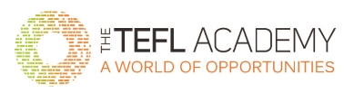

**RAFFAELE ESPOSITO**

**TEL:** +39 (0) 340 7156362

**EMAIL:** [raffaeleesposito02@gmail.com](mailto:raffaeleesposito02@gmail.com)

**ADDRESS:** Via Caio Duilio, 16/E, Naples, 80125, Italy

**SKYPE:** raffy180

**LINKEDIN:** <https://www.linkedin.com/in/raffaeleesposito02/>

**PROFILE**

I am a High School Diploma educated, qualified EFL teacher. I am a friendly and dynamic person, I like using creativity in my English lessons, and making people open-minded. I am very good at working in team and communicate well at all levels and ages. I define myself as an outsider, and remain committed to improving my teaching skills further and contributing to the success of the school.

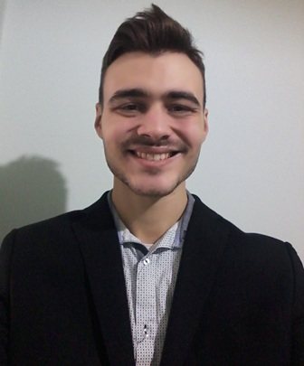

**TEFL TRAINING**

02 January 2021 **10-hour Teaching Practice Course (1-day course) - The TEFL Academy, UK**

In this 10-hour course I have put in practice everything I have learnt from the online TEFL course.  
  
Activities done:  
1) **Classroom Management** - How to deal with students, especially with difficult or distracted ones  
2) **Teaching practice 1** - Planning a lesson for pre-intermediate students concerning a video about self-driving cars  
3) **Teaching practice 2** - Planning a lesson for absolute beginners about "colors". I had to teach in my native language (Italian)  
4) **Teaching practice 3** - Planning a lesson for intermediate students about second conditional, by using **elicitation** and **Concept Checking Questions** (CCQs)

27 July 2020 – 30 July 2020 **TEFL Top-up course certificate - Teaching English Online & 1:1 (30hrs) - The TEFL Academy, UK**

Course included:

- Introduction to online teaching

- Setup and equipment needed for teaching online and an examination of the different platforms used for teaching

- What kinds of course you can offer online

- Tackling the challenges of teaching online, and planning courses for your students

- Work options: Teaching online independently or working for a company

5 June 2020 – 27 July 2020 **Level 5 TEFL Certificate (168hrs) - The TEFL Academy, UK**

Course included:

- Creating lessons and teaching materials for a range of levels from

Elementary to Advanced

- Teaching speaking, listening, reading and writing

- Material & resource creation, utilising the internet

- Needs analysis and teaching in different situations

- Classroom management and teaching techniques

- Language analysis – vocabulary, grammar and pronunciation

**EDUCATION AND COURSES**

2017 – 2018 Apple Developer Academy, University of Federico II, San Giovanni a Teduccio, Naples – 750hrs Standard Class course

I have attended the Apple Academy at the University of Federico II at San Giovanni a Teduccio, Naples, in my 750hrs Standard Class course. In this course, I dealt with a multilingual classroom; English was the mother tongue of this course and this gave me the opportunity to improve my English skills, especially speaking and listening.

2008 – 2012 ITIS Francesco Giordani, Naples – High School Diploma

**EMPLOYMENT**

March 2019 - September 2020 - **Software Developer, Accenture, Naples**

Project I have worked on: H&M

Activities:

- Developing new functionalities and bug-fixing by using Hybris e-commerce platform;

- Improving my English skills by working on an international project (H&M);

- Writing documentations, making presentations and taking Knowledge Transfer (KT) meetings in English to show the new functionalities developed for the project.

**HOBBIES/INTERESTS**

I adore studying new languages; it makes me open-minded, as I am able to talk to people around the world. Also, I like travelling and singing.

**PERSONAL DETAILS**

Date of Birth: 26th September 1992

Marital Status: Single

Health: Excellent

Nationality: Italian

Clean full driving licence