liezl wilson  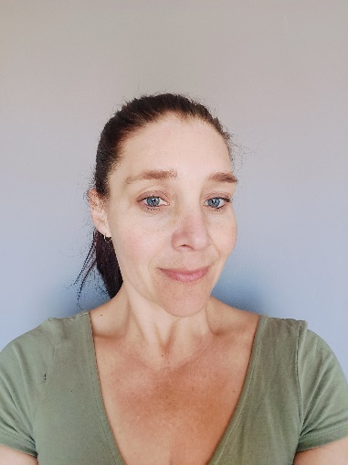  liezl.wilson@gmail.com  +27 (81)334-7944  ABOUT ME  I am a diploma qualified EFL teacher. I am an outgoing person who loves to work with people from all over the world. I enjoy learning about different cultures. Whether in a classroom or one to one lessons, I bring energy and fun into the lesson  HOBBIES  Running, learning new skills, interior designing, training  PERSONAL DETAILS  DATE OF BIRTH:1980-12-23  MARITAL STATUS: MARRIED  NATIONALITY: SOUTH AFRICAN  DRIVING LICENCE: YES  LANGUAGES SPOKEN: ENGLISH & AFRIKAANS | Experience  The only experience I can add here is homeschooling my own two children for the past 8 years. My eldest daughter has finished high school and my youngest daughter has 1.5 years left to finish. They both did the American GED syllabus.  TEFL TRAINING  Level 5 168 Hour TEFL Certificate – The TEFL Academy, UK.  - January 2019 – July 2019  - Grade  - Created lessons for a variety of levels from pre-intermediate to advanced  - Teaching speaking, listening, reading and writing  - Material & resource creation, utilising the internet  - English grammar and how to teach the essential language  - Needs analysis and teaching in different situations  - Classroom management and teaching techniques  Education  Degree / Date Earned  School  You might want to include your GPA and a summary of relevant coursework, awards, and honors.

EMPLOYMENT
I have not had any previous EFL employment as I only qualified in July 2024. I am super excited to add some employment to my list.

