

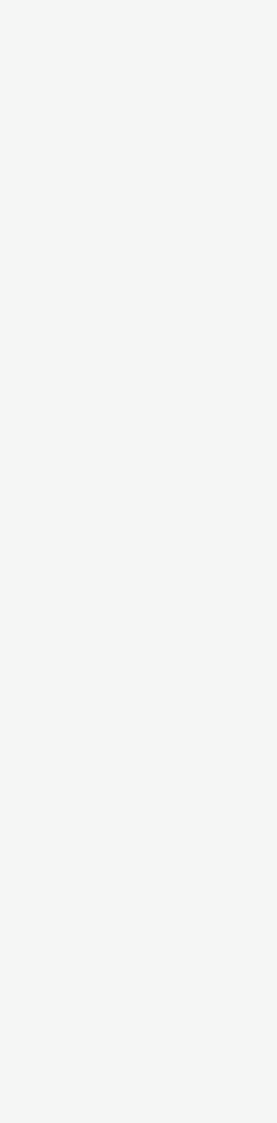

**Nishaat Abdollatief**

`

**Hobbies**

* Reading
* Crafting
* Going for walks

**Skills**

* Strong communication skills
* Creative
* Flexible
* Adaptable
* English: Native
* Afrikaans: Professional working proficiency

**Languages**

[nishaatabdollatief@gmail.com](mailto:nishaatabdollatief@gmail.com)



061 013 3067



South Africa.



**Contact Information**

Newly certified TEFL teacher with a love for the English language and a passion for helping others. I have strong communication skills, adapt easily, learn quickly, and am able to work well both individually and as part of a team. As a teacher, my lessons will be student-centered, with continuous monitoring of progress and regular feedback to ensure effective learning.

**Community Service Dietitian (Community Nutrition);**

**01 January – 31 December 2022.** *Department of Health, Nelson Mandela Bay, Eastern Cape,*

*South Africa*

* Planned and conducted dietetic services and activities in the communities placed, which include nutrition counselling, nutrition education, campaigns and outreaches.
* Counselled patients referred by doctors and other healthcare professionals and those identified through screening in waiting areas and on outreaches.
* Progress was monitored and support provided through motivation and addressing setbacks and challenges that arose.

**Community Service Dietitian (Clinical Nutrition);**

**04 July – 12 August 2022.** *Livingstone Hospital, Port Elizabeth, Eastern Cape, South Africa*

* Conducted comprehensive nutritional assessments using the ABCD approach.
* Monitored and documented patients' nutritional status, progress, and dietary adherence, adjusting as necessary.
* Educate and counsel patients and families on dietary recommendations, therapeutic diets, and lifestyle modifications to support their medical treatment.

**Work History**

**Work History**

**120 Hour Teaching English as a Foreign Language Certificate**

*Teacher Record, 2024*

**BSc Dietetics**

*Nelson Mandela University, Port Elizabeth, South Africa,*

*2018 – 2021*

Majors:

* Therapeutic Nutrition
* Food Service
* Community Nutrition
* Dietetic Treatise

**National Senior Certificate**

*Uitenhage High School, Uitenhage, Eastern Cape, South Africa, 2015*

**Education**

**Skills**

Nutritional Assessment and Counselling

Medical Nutrition Therapy

Health Education and Promotion

Dietary Supplements

Computer Literacy

Date of birth: 16 February 1997

Nationality: South African

Race: Coloured

Gender: Female

Marital Status: Married

Health: Excellent

Valid driver’s license

HPCSA registration: DT 006 1433