**CURRICULUM VITA**

**E**

**OF**

**CHARNEY LESHAAN MINNIES**

**Financial Advisor**

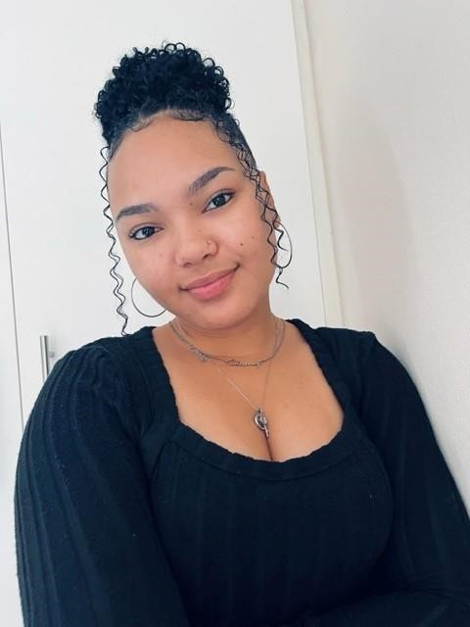

# PROFILE

I am a goal driven young lady; I enjoy working with people regardless of their different personalities. I am always willing to learn new things, therefore I am not close minded.

# CONTACT

Personal Cell: 0780728306

Work cell: 0605395489

EMAIL: Personal:

minniescharney@gmail.com Work: cminnies@oldmutual.com

# ADDRESS

10 Reo Reid, Sherwood, Port Elizabeth

## HOBBIES

Sports (Hockey &Athletics)

Music

Socializing with others

Hiking

Traveling (going on Adventures)

Cooking

### EDUCATION

#### Riebeek College Girls High School

2014-2018

I passed my Matric with a bachelor’s Pass.

#### Nelson Mandela University

2019-2023

Started studying Bachelor of Arts majoring in Psychology and Sociology.

#### Alison Institution

2022-2023

Diploma in HR

Certificate in Facilities Management

Certificate in TEFL

### WORK EXPERIENCE

#### Rowlans Fashion – Sales Assistant

2019-2022 (MR K Pillay – 0727134006) I learned to work with people with different personalities. I also learned how to do the IQ systems on the computers. This is also where O learned my communication skills.

#### Old Mutual – Financial Advisor

2022- Current (Mrs. Z Xata – 0721337673) The best decision I made was to move over to the finance world. Finance and communication are my strongest points. In this company I can be myself and I’ve been reaching excellent heights.

### SKILLS

* Good with presentations
* Good with communication
* Excellent Computer skills (Excel, Word, PowerPoint)
* Works well under pressure
* Highly organized
* Good with Bookkeeping
* Excellent problem-solving skills

**Driver’s license:**

Code B

