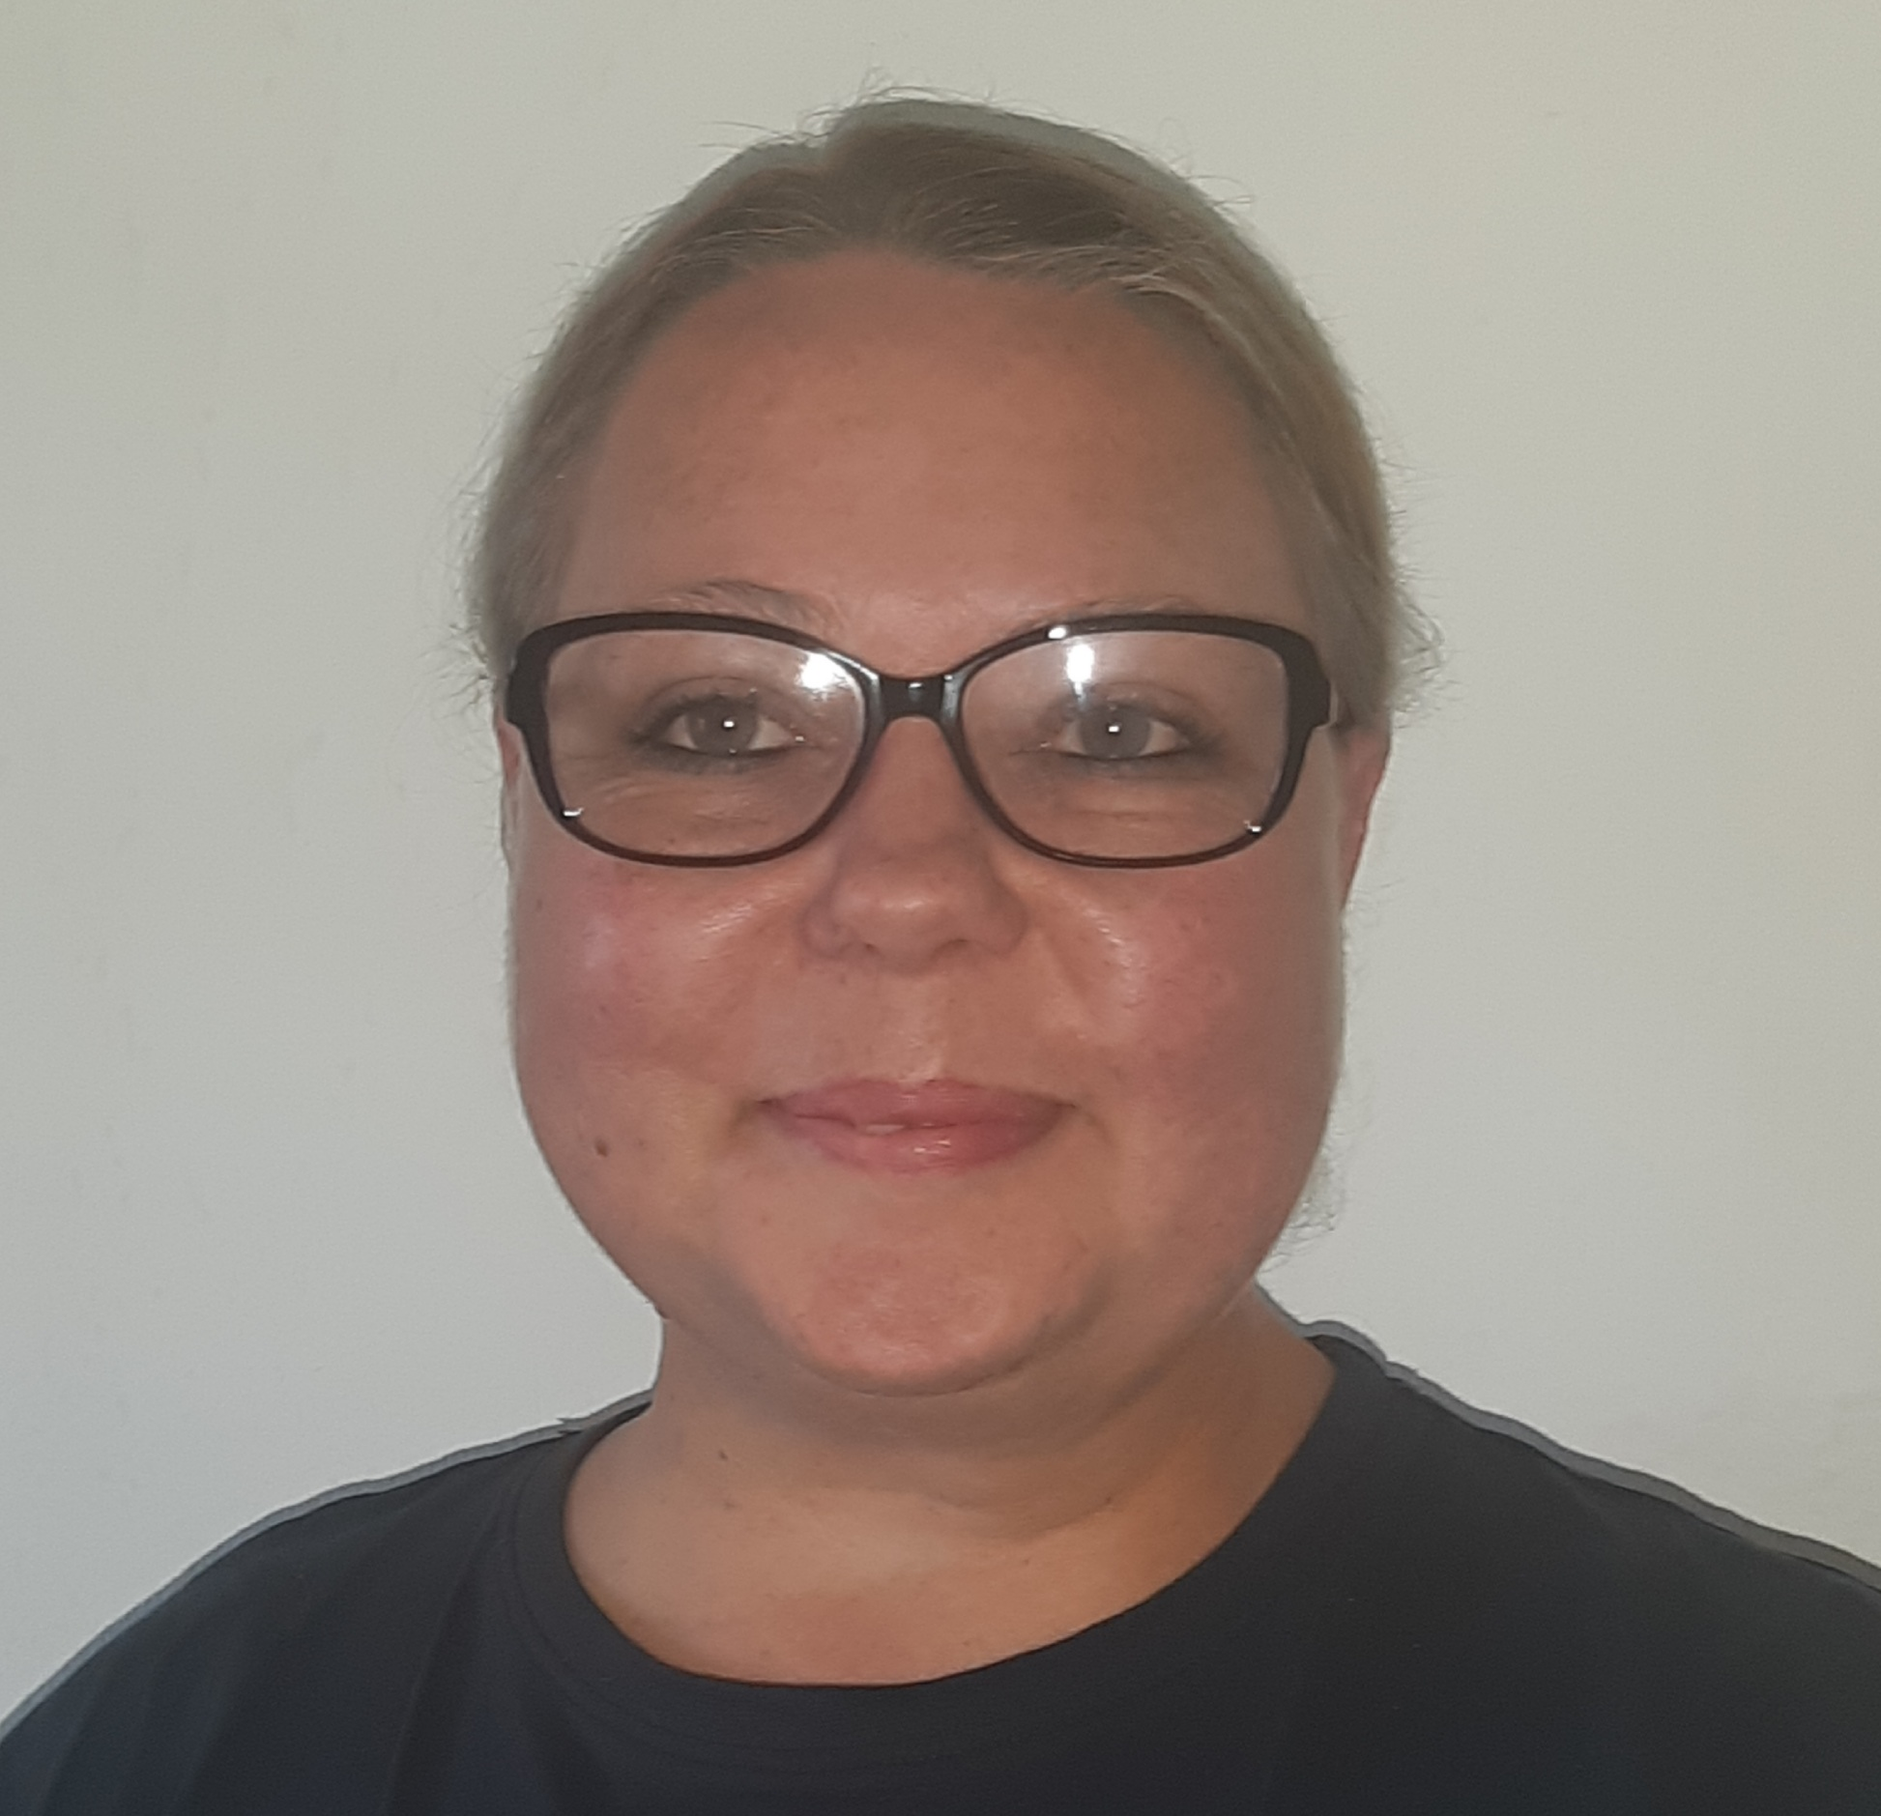 |  | Elsabe Zylstra  Online English Teacher / Tutor
~Teaching is not a one-size fits all. I’m an adaptable, patient and passionate teacher. I focus on pronunciation, intonation, and speaking.  Get in touch with me  PHONE:  +27722415752  SKYPE:  Elsabe Zylstra  live:.cid.558f0108917099ec  EMAIL:  elsabzlstr@gmail.com  PLATFORMS  VooV  QQ  Zoom  TECHNOLOGY  -Laptop with build in camera  -Memory RAM 8.00GB  -External hard drive 1.00TB  -Noise cancelling headset  -Stable internet connection with  60Mbps upload and download  speed on fixed fiber line  -Back-up generator |  | EDUCATION  Teach TEFL Language School  TEFL Certificate – Completed November 2020  - Teaching skills: Presentation, Practice  - Pronunciation, Phonics, Vocabulary, Grammar  - Motivating students  - Adjusting to student’s ability and understanding  WORK EXPERIENCE  Professional Online English Teacher / Tutor  BesTutor / February 2022–Current  Teach reading, writing, pronunciation and spoken English to young learners and adults.  Young learners:  Pre-school, Primary school, High School  English Level: Zero, Beginner, Elementary, Intermediate  Lesson type: One-on-one  Learning material:  - Let’s Go series  - McGraw-Hill Wonders Series  - Side-by-Side Series  - National Geographic Reading explorer Levels 2 & 3  - Phonics, grammar, vocabulary  Adults learners:  English Level: Elementary, Intermediate, Upper intermediate  Lesson type: One-on-one  Learning material:  - IELTS Speaking  - Business English  - College Interview  - Job Interview  - Daily Conversational English  Professional Online English Teacher  Dazao Speaking School / April 2021–August 2021  - Students: Age 3-17, Pre- and Middle Schoolers  - Lesson type: One-on-one  - Level: Beginner, Intermediate, Exam Preparation

