Curriculum Vitae of Wian Obbes |  | 064 654 2663  Wianobbes@gmail.com
OVERVIEW | Dynamic customer service professional with hands-on experience in waitering, adaptability, and a passion for learning. Holds a comprehensive IT Engineering certificate with expertise in system administration, network management, and software development, along with a 150-hour advanced TEFL/TESOL Certificate. Eager to contribute skills in a diverse team environment.
EXPERIENCE | SPUR | 02/2023 - 06/2023 | Waiter
- My responsibilities were greeting and seating customers, taking orders, serving food and beverages, maintaining cleanliness, and providing excellent customer service to ensure a positive dining experience.
- The skills I learned include:
  - Working under pressure
  - Prioritizing tasks efficiently
  - Customer Service
Code B driver’s license
EDUCATION | Hoërskool Duineveld
 | 2017 - 2021 | National Senior Certificate
- Afrikaans – Pass
- English – Pass
- Mathematical Literacy – Pass
- Information Technology – Pass
- Computer Application Technology – Pass
- Life Sciences – Pass
- Life Orientation - Pass

IT Academy (Optimi College)
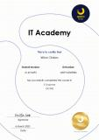
 | 2022 - 2023 | IT Engineer
Google (Google Analytics Academy)
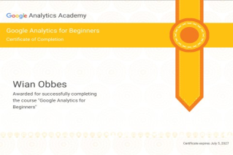
2024 – 2024 Google Analytics

EF Standard English Test
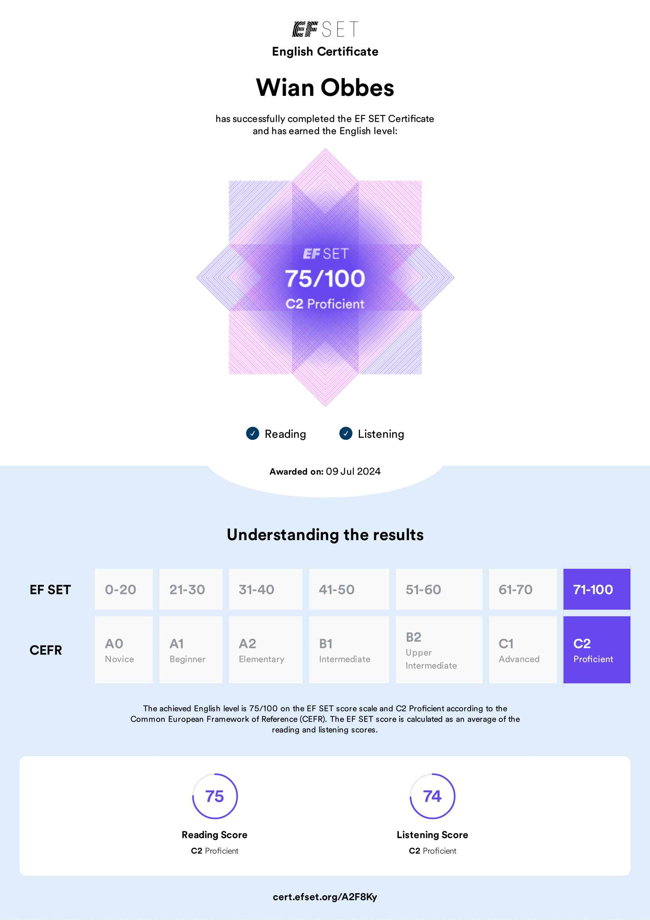
2024 – 2024

150 Hour Advanced TEFL/TESOL Certificate
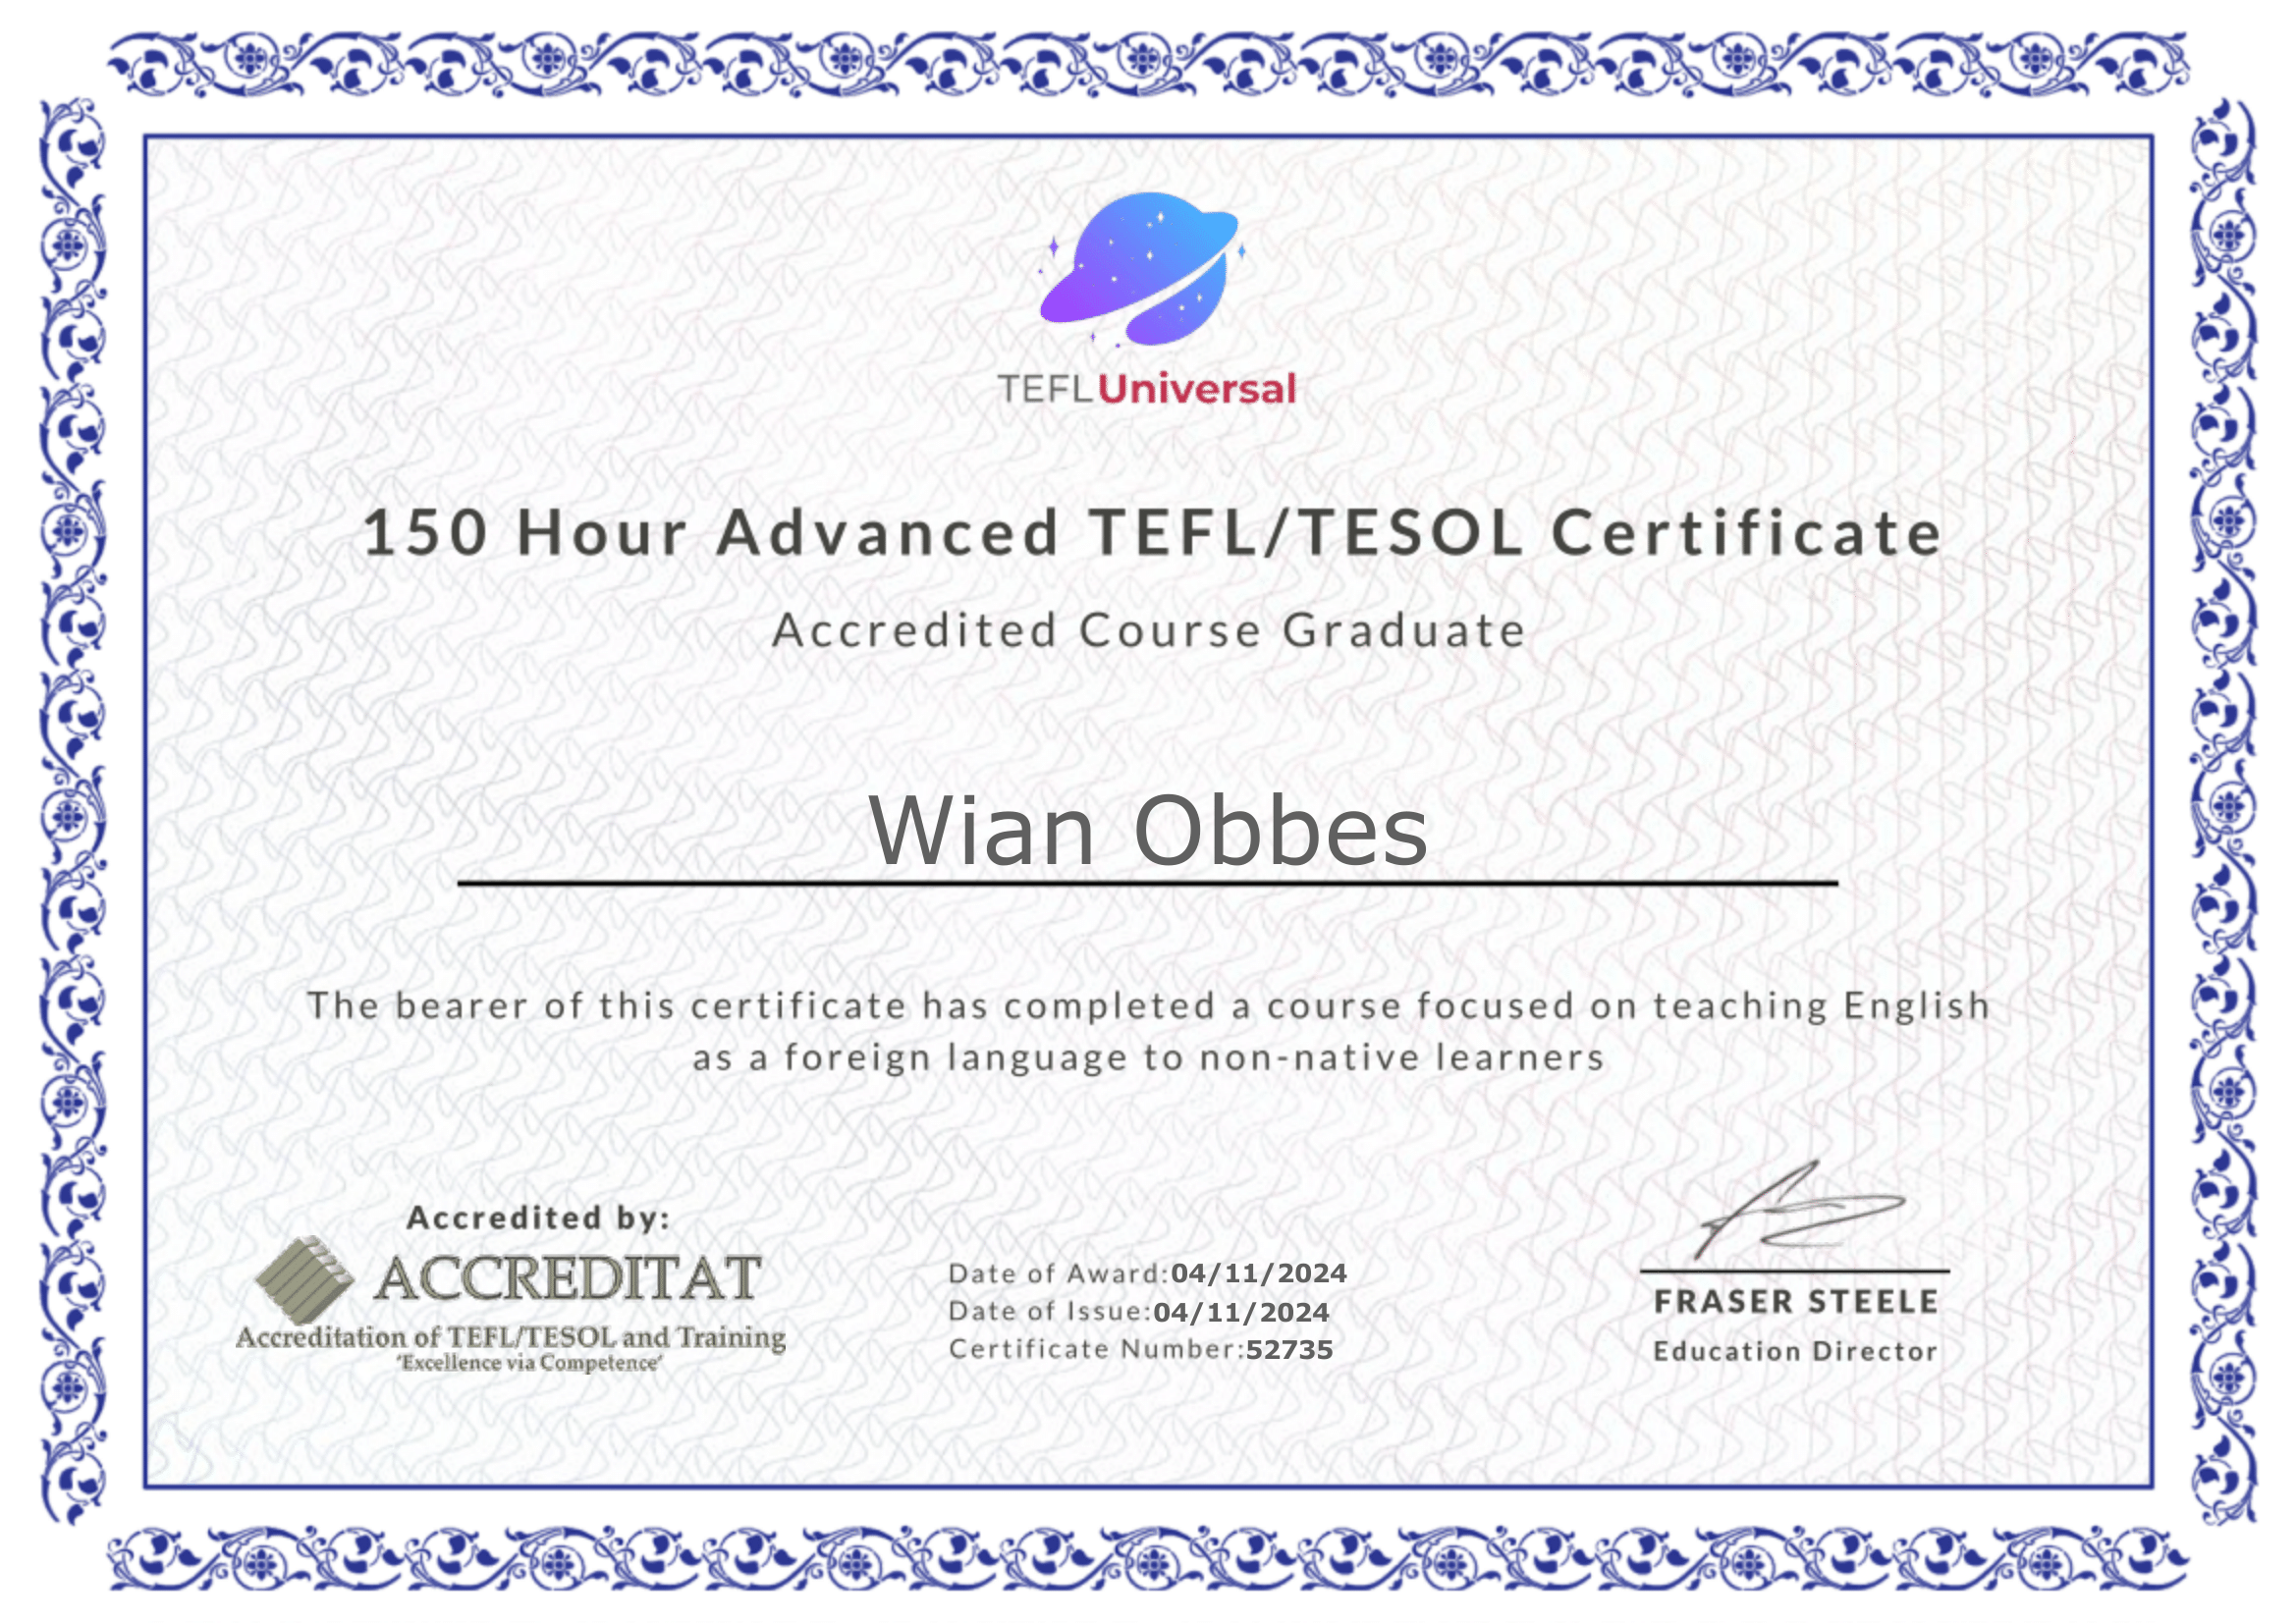
2024 - 2024
SKILLS | Customer Service/ Teaching English/ Computer Literacy

