Eden de LANGE  edendelange85@gmail.com  +27 67 372 3198  ABOUT ME  I am a newly qualified EFL teacher. I enjoy using my creativity to produce stimulating lessons to inspire and engage a class. I can work well in a team environment and can communicate effectively at all levels and ages.  HOBBIES  I enjoy reading and playing instruments such as guitar and piano and I enjoy all forms of art.  PERSONAL DETAILS  DATE OF BIRTH:21/12/2005  MARITAL STATUS:none  NATIONALITY:South African  DRIVING LICENCE:none  LANGUAGES SPOKEN: English, Afrikaans and basic Korean skills  REFEREES:  Contact: Haley  (Head of pre-school)  +27 79 445 5932 | Experience  I worked for one term (3 months) in a preschool, ages 4-6, as a teachers assistant teaching first language Xhosa children English.  TEFL TRAINING  Level 5 Combined 168 Hour TEFL Certificate – The TEFL Academy, UK.  Completed - November 19th 2024  Grade - Pass  Accredited Level 5 TEFL course, equivalent to a CELTA or Trinity CerTESOL, with comprehensive training in teaching English as a foreign language.  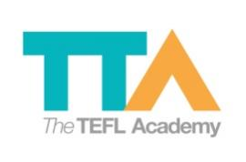  Education  School- Port Shepstone High school  I have completed my grade 10 in 2021.  School- The TEFL Academy  I have completed my TEFL Level 5 course end November 2024.

EMPLOYMENT
Ithuba Wild Coast Community College, Grade 0-7.

