***Curriculum Vitae***

***Thomas Dichmont***

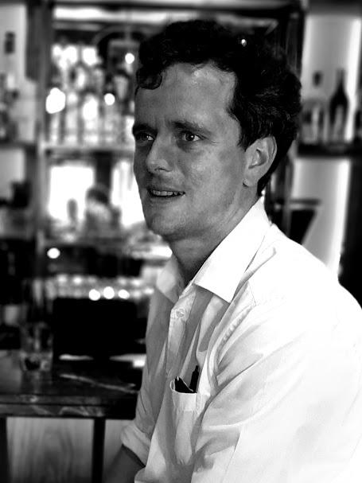

Name: Thomas

Surname: Dichmont

Availability : Immediate

Drivers License : Yes ( Code 08 -SA) DOB: 1993/10/1993

Age: 30 years

Gender: Male

Race: White

Disabilities: None

Language: English

**CONTACT**

Phone: +27 (076 990 8864)

Email: Thomasdichmont@gmail.com

My last post was at Athletic Club and Social, a popular jazz club in the Cape Town CBD. My work involved organising and helping to promote the events. As to the second part, I would post the promotional material. I also help generate some of the promotional content by writing bios of artists into manageable chunks that can be quickly digested, while giving it some persuasive force that is consistent with the brand and the artist's vision.

From 2018-2022 I was doing my masters degree in philosophy, by dissertation alone. My thesis concerned Ockham’s Razor, a principle of logic which states, “All things being equal, chose the simpler solution.” The aim of my thesis is to investigate what justifies the inference, where does the principle come from and how should we understand it.

Before my masters, I did a combined Honours, in Philosophy and Classical Civilisation. Prior to that an undergraduate degree in Legal Theory, Classical Civilisation and Philosophy. Legal Theory is a preparation for legal practice. Classical Civilisation is an English language introduction to ancient civilisation, with a focus on those of Greece and Rome. Philosophy concerns itself with inquiry into first principles.

During that time (2015), I started working for Friar Tucks Pub and Grill. This is a popular nightclub for Rhodes students. I started working there as a barman to make a supplementary income. That same year I applied and succeeded in acquiring a J1 visa to the United States, where I worked at a hotel in Texas. I have always been fascinated by America, and this was an opportunity to satisfy my curiosity. In 2016, I started tutoring for the Classics department. Later, in my masters I shifted to tutoring philosophy.

My thesis and the associated challenges have demonstrated my ability to continue in adversity. It has also taught me the value of having clear goals and sticking purposefully to them. Being a barman had the difficulties of being a high-pressure and fast-paced environment, coupled with long, twilight-hour work. But it taught me to value the comradery such environments create. Getting a J1 visa was a cumbersome process, which familiarised me with government bureaucracies, to some extent, while actually working in America, was an invigorating experience and imparted some of the ‘go-getter’ attitude of the country. Tutoring has taught me to be patient and diligently punctual, while also having to be organised in order to meet deadlines while having to deal with student’s excuses. Philosophy has taught how to think through alternatives, in a way not dissimilar to ‘red teaming’, a practice designed to discover flaws in plans and operations. It has also given me a wide array of mental tools with which to solve various problems that present themselves.

ACADEMIC RECORD

| **University/ Institution** | **Dates Degree, Diploma, Certificate**  **Obtained** |
| --- | --- |
| Rhodes University | Jan 2018 – Feb 2022  Masters :  Dissertation  - Philosophy  completed in February 2022  Title : The ontology of  parsimony arguments. |
| Rhodes University | Jan 2017 – Dec 2017 Honours :  – Classics and Philosophy |
| Rhodes University | Jan 2013 – Dec 2016 Bachelors of Arts : (Triple Major )  - Legal theory  - Classics  - Philosophy |
| St. Georges Grammar School | 2012 Matric Certificate |

**WORK EXPERIENCE**

**Last Appointment** :

**Name of Organisation**: Athletic Club and Social

**Nature of Employmen**t: Internship

**Name of Referee**: Athos Euripidou

**Held from**: 02/05/2022 til 22 September 2023

**Reason for leaving**- I have opted to pursue alternative avenues, including freelance writing.

**Nature of business:** restaurant, whisky bar and jazz club Description

- A general assistant to the owner

- Writing any promotional material for the club

- Basic administration duties relating to the jazz performances - Greeting guests

- Waiting tables

- Assisting and managing staff

- Some administrative duties relating to signing of invoices.

**Name of referee**: Athos

**Position**: Owner

**Referee contact number**: 082 7770477

**Previous Appointments:**

**Name of organization**: Rhodes University

**Nature of Employment:** The undertaking of my Master’s thesis in Philosophy.

**Name of referee**: Francis Williamson (supervisor)

**Position**: Head of Department

Referee contact number: 082 780 4824

**Name of organization**: Rhodes University (as tutor)

**Held from**: January 2016 – December 2020.

**Nature of its business**: School of Languages (2016-18) (Philosophy 2019-2020)

**Position**: Tutor, first Classics, then philosophy

**Description**

- Provide crucial support to students via feedback. I would often try to refer to the how and why of where they went wrong.

- Marking of work and its collation and presentation for use in mark allocation.

- As tutors we were a communication link between academic staff and the students, communicating the students’

occasional misunderstandings to the lecturer of the course.

- Attending general meetings, where the week’s work was discussed and the outline of what was expected of the students was given.

**Reason for leaving** :

- In 2020, to focus on my thesis.

- In 2019, In the case of leaving classics, it seemed appropriate that I should be a tutor in the subject I was doing my masters in.

**Name of referee**: Francis Williamson.

**Position**: Head of Department, Philosophy

**Referee contact number**: 082 780 4824

**Name of refere**e: Danial Malamis

**Position**: Section Head, School of Languages

**Referee contact number**: 083 504 8006

**Previous Appointments and activities**

**Name of organization**: Gaylord Texan Hotel Grapevine (Texas USA) Held from: 2015 November to January 2016

**Nature of its business:** Hospitality

**Position: Exhibition:** Assistant

**Description:**

Temporary work opportunity at hotel in Texas, through specialist company, OVC.

- I was responsible for assisting both VIP and non-VIP attendees of the ICE exhibit. This was an exhibit of Christmas themed- ice sculptures in a refrigerated tent.

- My duties included ensuring needs of the attendees were met, in the case of non- VIP attendees, there were essentially five duties; principally the distribution and packing of parkas to keep the attendees comfortable during their visit. This involved the delicate matter of sizing people at a glance.

- Secondly there was a door to the tent that needed to be closed as much as is possible, but the clients needed to be let in, so our job was to close it after them. This also involved advising the attendees to avoid bodily and or oral contact with the ice.

- One the features of the exhibit was a slide made of ice. Principally what we had to is make sure no two people were on the same slide at the same time, hard soled shoes were prohibited and that young children did not go on the ‘adult’ slide.

- there were photography duties in the exhibit and there was a bar in the tent that needed manning.

- The VIP attendees required much the same as has been delineated above, but had their own, quick queue and therefore need to be guided through the hotel by workers.

- All these duties had to executed with a cheery disposition and professionalism.

REASON FOR LEAVING :

- The contact for the program had a stipulated period, so that once that period expired so did my contract.

**-**

**Name of referee**: Robyn Surgeson

**Position**: Franchise Owner (OVC)

**Referee Contact Numbe**r: 084 900 2787

**Previous Appointments**

**Name of organization**: Friar Tuck’s Pub and Grill

H**eld from**: March 2015 – October 2015

**Nature of its business**: Restaurant and Bar

**Position**: Barman

**Description:**

- My duties included, stock management, this was an hour done before the bar opened for business and involved weighing or counting and then recording the individual alcohol stocks. The same process was done after closing time. Any stock

discrepancies had to be reconciled.

- Dealing with customers, quickly and efficiently, making as few mistakes possible. As was said there was a fair degree of pressure here as there were a large number of thirsty customers

- The stock management system or ordering system that was used was called ‘Odyssey’.

- The bar also had to be clean at all times and had to be civil with the clients as much as possible.

-

**Reason for leaving :**

- I chose to focus on exams and so left my position.

Name of referee: Katy

Position: Owner and manager

Referee contact number: 082 418 7246