cHANTELLE kNOETZE  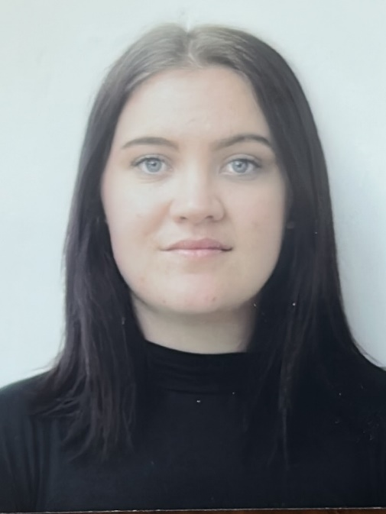  KNOETZECHANTELLE@ICLOUD.COM  (+27) 66 406 3229  ABOUT ME  I am an educated, qualified TEFL teacher. I enjoy using my creativity to produce stimulating lessons to inspire and engage a class. I work well in a team and can communicate effectively at all levels and ages.  HOBBIES  PAINTING, DRAWING, HIKING, CAMPING, READING, COOKING AND BAKING.  PERSONAL DETAILS  DATE OF BIRTH: 2003/04/29  MARITAL STATUS: Single  NATIONALITY: South-African  DRIVING LICENCE: Yes  LANGUAGES SPOKEN: Afrikaans & English | TEFL TRAINING  Qualifi Level 5 Diploma in Teaching English as a Foreign Language (The TEFL Academy)  - Awarded on 24 January 2025  - Introduction to Lesson Planning  - Teaching English Vocabulary  - Teaching Pronunciation  - Understanding English Grammar  - Teaching Receptive skills: Listening & Reading  - Teaching Productive Skills: Speaking & Writing  -Teaching English Grammar  -History of the English Language and English Language Teaching  -Teaching Materials and Aids and Classroom Management Strategies  -The Effective use of Resources for TEFL

Education

Degree / Date Earned

-H/s Tuine:
National Senior Certificate, 2021

-SANTS Higher Education:
BEd Intermediate Phase, 2025 (First Year)

