**Jennifer Ann Bartlett (nee Johnstone)**

**Telephone no : (+27)827596081**

**Email: jennyabartlett@gmail.com**

**Address:** 12 Kamberg Road, Rosetta, Kwazulu-Natal, South Africa

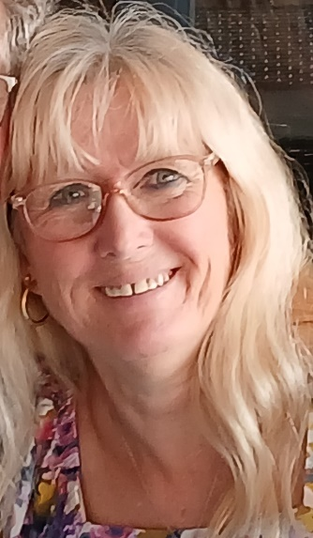

**Profile**

I am a degree educated, qualified EFL teacher. I am a native born English speaker. I speak a bit of Afrikaans and a smattering of French. I enjoy being creative and am keen to use this creativity to create stimulating lessons to inspire a class. I work well in a team or individually and can communicate well at all levels and ages. I have a variety of outside interests and am committed to improving my teaching skills further and contributing to the success of the school.

**TEFL Qualifications**

**2024 Qualification Level 5 Diploma in Teaching English as a Foreign Language (168 hours)** **- The TEFL Academy**

* Ofqual regulated Level 5 qualification, DEAC approved
* Lesson planning, Classroom management, Teaching vocabulary and pronunciation, Teaching receptive and productive skills, Teaching grammar, Materials development for face-to-face and online lessons, Assessed lesson content for A1-C2 level students.

**2025 Teaching English Online and One to One (TEFL) (30hrs)- The TEFL Academy**

* Accredited short course specializing in teaching English online and one to one teaching

**Education & Courses**

1987 – 1989 Batchelor Oral Health (B.OH), University of Durban-Westville,

Now named University of Kwazulu-Natal

1986 Certificate of Dental Assisting, Technikon Natal

**1979 – 1885 3 ‘A’ levels in English, Mathematics and Biology. 7 ‘O’ levels**

**St. Andrews Secondary School, Blantyre, Malawi**

**Relevant Experience**

I taught Preschoolers, age 18 months to 4 years of age for 6 years. I worked as an Oral Hygienist and Dental Assistant for 17 years in busy dental practices. One of my roles in these jobs was to teach people how to look after their teeth. I have also helped teach Preschoolers remedial work.

**Employment**

1990 to 1995 Employed as an Oral Hygienist

Took time out to get married and have 2 children

2004 to 2009 Taught at a Preschool

2008 to 2018 Employed as an Oral Hygienist and Dental Assistant

2019 to present admin for my husband’s business and for studying TEFL qualifications

**Hobbies & Interest**

I enjoy gardening, reading and needlecrafts. I enjoy singing and playing the guitar at home and in church. I keep fit by cycling and doing Pilates.

**Personal Details**

**Date of Birth:** 30th December 1966

**Nationality:** British

South African by naturalization 1990

**REFERENCES ON REQUEST**