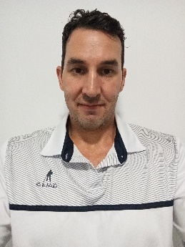
Marc Carbone
Perth, WA
m_c1987@Outlook.com
0473876621

Summary
Motivated and adaptable TEFL student passionate about teaching, seeking to inspire students and grow professionally in dynamic educational environments

Career History
Fitness Instructor – Movement Co
March 2023 – October 2023
Before/After School Educator – Big Childcare
March 2023 – currently employed
After School Educator – Randstad Education
February 2022 – March 2023
Disability Support Worker – One 2 O2ne
October 2021 – March 2023
Disability Support Worker – Valued Lives
February 2021 – November 2021
Group Fitness Trainer – Goodlife Health clubs
January 2011 – October 2021
Fitness trainer – Murdoch University Gym
November 2007 - October 2010

Skills/Attributes
- Child/adult Engagement
- Adaptability
- Effective Communication
- Team Collaboration
- Time Management
- Problem-Solving
- Patience
- Empathy
- Organizational Skills
- Health and Safety Awareness

Education/Qualifications & Licenses
Diploma of Fitness – Onfit Training College
Graduated 2013
Level 5 Teaching English as a Foreign Language Course (TEFL) – The TEFL Academy
Completed and qualified March 2025

