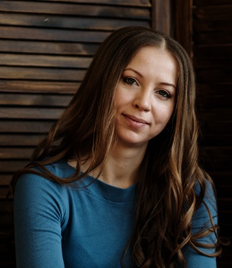

**Anna Kudryavtseva**

**English Language Teacher**

**Contact Information**

📞 Phone: +7 (916) 251-97-40  
✉ Email: [anna-fom@yandex.ru](https://mailto:anna-fom@yandex.ru/)  
📍 Location: Korolyov, Russia

**Personal Information**

* **Citizenship**: Russian Federation
* **Education**: Higher (Linguistics)
* **Date of Birth**: April 30, 1984
* **Gender**: Female
* **Marital Status**: Married (with children)

**Work Experience**

**Language Center "Dialog" LLC (September 2013 – Present)**

**English Language Teacher**

* Conduct group and individual lessons for students of all ages (children, teens, adults) in **both in-person and online formats**.
* Prepare and administer midterm/final assessments.
* Provide progress reports to parents/guardians.
* Organise and participate in extracurricular activities.
* Use interactive whiteboards and digital resources.
* Teach with **authentic Cambridge materials** (Kid’s Box, Prepare, English in Mind, Face to Face, Super Minds).
* Prepare students for **Cambridge English Exams**.

**Russian State Social University (September 2006 – July 2008)**

**Lecturer, Department of Foreign Languages**

* Taught beginner-level university students.
* Designed assessment materials.
* Participated in academic research.

**Education**

**Russian State Social University**

* **Faculty**: Foreign Languages
* **Specialization**: Theory and Methodology of Teaching Foreign Languages and Cultures
* **Graduation Year**: 2006
* **Study Mode**: Full-time

**Certifications & Training**

* **The Practical English Usage Course “Successful Exam Strategies: C2 Proficiency”** (2024)
* **250 Hour Expert TEFL/TESOL Course** (2024)
* **Teacher Training: Task-Based Learning for Classroom Communication** (2018)
* **Seminar “Early Literacy Teaching Methods”** (2017)
* **Seminar “Teaching Teenagers”** (2016)

**Additional Information**

**International Certificates:**

* **2006**: FCE (Grade A)
* **2013**: CILS (Italian language)
* **2024**: TEFL/TESOL Certificate (Grade A)
* **2025**: C2 Proficiency (Grade A)

**Career Break:**

April 2019 – January 2025: Parental leave. During this time, completed **TEFL/TESOL and C2 Proficiency courses** to maintain professional skills.

**About Me:**

Dedicated and passionate educator with a focus on student-centered learning. Committed to professional growth and fostering a positive classroom environment.