Frank Rodasky  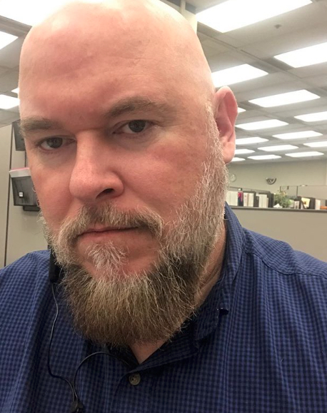  frankrodasky@gmail.com  704-992-4719  Link to other online properties: Portfolio/Website/Blog  ABOUT ME  I am a bachelor’s and master’s degree educated, soon to be qualified TEFL teacher. I enjoy using my creativity to produce stimulating lessons to inspire and engage a class. I work well in a team and can communicate effectively at all levels. I prefer to teach to adults 18 and up as well as young adults ages 12 and up.  HOBBIES  HISTORY, TRAVEL, READING, WRITING, BLACKSMITHING, HIKING  PERSONAL DETAILS  DATE OF BIRTH: 10/08/1972  MARITAL STATUS: SINGLE  NATIONALITY: AMERICAN  DRIVING LICENCE: R627-816-25-300-0 (FLORIDA)  LANGUAGES SPOKEN: ENGLISH  REFERENCES:  DAVE CLAWSON  (360-362-9419)  NICOLE YOUNG  (916-524-7010)  STEPHANIE TURKOWSKI  (806-729-9236) | Experience  Volunteering at Literary Services of Indian River County in Vero Beach, Florida (772-778-2223, contact: Kelly Bradley). Assisting Mike Godown in his weekly adult literacy class.  TEFL TRAINING  Level 5 168 Hour TEFL Certificate – The TEFL Academy, UK.  - March 2025 – September 2025 (Expected Completion Date)  - IN PROCESS  Education  MASTER OF PUBLIC ADMINISTRATION/2012  University of Texas, Arlington, Texas  Urban Management-3.33 CGPA  BACHELOR OF SCIENCE, mass communication/2010  West Texas A&M University, Canyon, Texas  Mass Communications/Journalism-3.063 CGPA, Honor Roll and Dean’s List  EMPLOYMENT  ASSOCIATE ANALYST  AMLR RIGHTSOURCE  CLEVELAND, OH  NOVEMBER 2022-PRESENT (REMOTE)  ANTI-MONEY LAUNDERING AND FINANCIAL CRIMES ANALYST AND INVESTIGATOR  DEPUTY CLERK III  SACRAMENTO COUNTY COURT SACRAMENTO, CA  SEPTEMBER 2016-SEPTEMBER 2020  CIVIL COURT CASE FILINGS CLERK, RECORDS RETENTION AND MANAGEMENT  MANAGING EDITOR/REPORTER  FORT STOCKTON PIONEER  FORT STOCKTON, TX  APRIL 2014-DECEMBER 2014  REPORTER PROMOTED TO MANAGING EDITOR FOR WEEKLY COMMUNITY NEWSPAPER. WROTE NEWS ARTICLES, CONDUCTED INTERVIEWS AND RESEARCH, TOOK PHOTOGRAPHS

