**Ali Bal**

**t:** +90 533 705 02 54

**e:** ali.balll@icloud.com

**Address:**  182 Akcatarla Avenue, Nusaybin, Mardin, Turkey, 47300

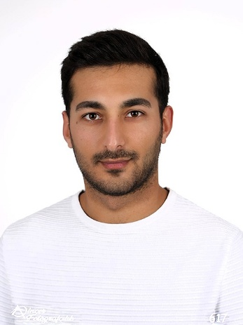

**Profile**

I am a qualified EFL teacher and holder of bachelor degree in ELT. I have experienced teaching for adults and young learners before. I valued, respected and enjoyed teaching since my very first lesson working in the field. The school I was working closed down during pandemic due to financial issues and I had to work in a different field. However, I have always remained connected to my passion for teaching. I enjoy tailoring my lessons to suit the diverse needs and interests of learners. I find it essential to weave my lessons around authentic materials involving both the theme and syllabus. As an innovative teacher, I place special emphasis on integrating technology and web 2.0 tools into my lessons**.** I also strongly believe that accessibility and inclusivity are essential components of education. I value collaboration with fellow teachers and, when necessary, with families, to support utmost student success. I am a detail-oriented perfectionist possessing strong teamwork and communication skills, and I am eager to contribute these qualities to your school.

**TEFL Qualifications**

**2024 Qualifi Level 5 Diploma in Teaching English as a Foreign Language (168 hours)** **- The TEFL Academy**

* Ofqual regulated Level 5 qualification, DEAC approved
* Lesson planning, Classroom management, teaching vocabulary and pronunciation, teaching receptive and productive skills, teaching grammar, materials development for face-to-face and online lessons, assessed lesson content for A1-C2 level students.

**2024 Teaching Young Learners (TEFL) (30hrs)- The TEFL Academy**

* Accredited short course specialising in teaching young learners.

**2024 Teaching English Online & 1:1 Course - The TEFL Academy**

* Accredited short course specialising in online and 1:1 teaching.

**2024 Teaching Business English (TEFL) (30hrs)- The TEFL Academy**

* Accredited short course specialising in teaching business English.

**Education & Courses**

2015 - 2021 **English Language Teaching - Mersin University**

- Observed teaching practice, contextual grammar, teaching receptive and productive skills, oral communication skills, introduction to pedagogy, advanced reading and writing skills, lexical competence*, English literature and its implementation in ELT, linguistics and its implementation in ELT*, approaches to ELT, oral expression and public speaking, language acquisition, ELT methodology, material adaptation and development, material evaluation, teaching English as a second language, teaching English to young learners, language education with adults, English language testing and evaluation, Drama and its implementation in ELT, computer assisted language teaching & learning

**Employment**

May 2024 – October 2024 **Activities & Events** **Manager, Oludeniz Beach Resort, Oludeniz, Turkey**

**- Brief overview of responsibilities:** Communicating with guests, refereeing adults pool games and activities, teaching new employees job skills. Building a rapport between the staff members; solving their problems.

April 2022 – November 2023 **Resort Customer Helper, Jet2holidays, Dalaman region, Turkey**

**- Brief overview of responsibilities:** Dealing with customer complaints and providing a solution to them. Dealing with incidents and writing reports. Offering help to customers. Selling excursions to holiday makers.

December 2021 – April 2022 **Adults &Young Learners English Teacher, US BOSTON Language Schools, Mersin**

**- Brief overview of responsibilities:** Teaching A1 level adults, B1-B2 level teenagers, A2-B1 level kids. Preparing lesson plans including four skills. Evaluating & adapting materials to be used in the classroom. *The school was closed down due to financial reasons during Covid-19 pandemic.*

May 2020 – October 2020 **Activities & Events** **Assistant Manager, Montebello Resort Hotel, Oludeniz, Turkey**

May 2019 – October 2019 **Activities & Events** **Assistant Manager, Montebello Resort Hotel, Oludeniz, Turkey**

**- Brief overview of responsibilities:** Communicating with guests, refereeing adults pool games and activities, teaching new employees job skills. Building a rapport between the staff members; solving their problems.

May 2018 – October 2018 **Kids** **Club Host, Montebello Resort Hotel, Oludeniz, Turkey**

**- Brief overview of responsibilities:** Responsible for (mainly British) children’s activities such as painting, playing games, singing and mini club activities.

**Hobbies & Interests**

I enjoy meeting new people and exchanging cultural values and languages with them. History is a real passion of mine; I enjoy conducting research and reading historical essays and magazines, as well as watching related documentaries. Traveling is another hobby I greatly enjoy. Although I haven’t had the opportunity to travel abroad yet, I have visited many places across Turkey. Music is also an important part of my life. I play the *bağlama*, a traditional Anatolian instrument, at an intermediate level. Additionally, I enjoy staying active through home workouts, going to the gym, and playing table tennis.

**Personal Details**

**Date of Birth:** 1st August 1997

**Ethnicity:** Kurdish

**Nationality:** Turkish

**REFEREES ON REQUEST**