TAIWO ANIFOWOSE

TEFL CERTIFIED TEACHER

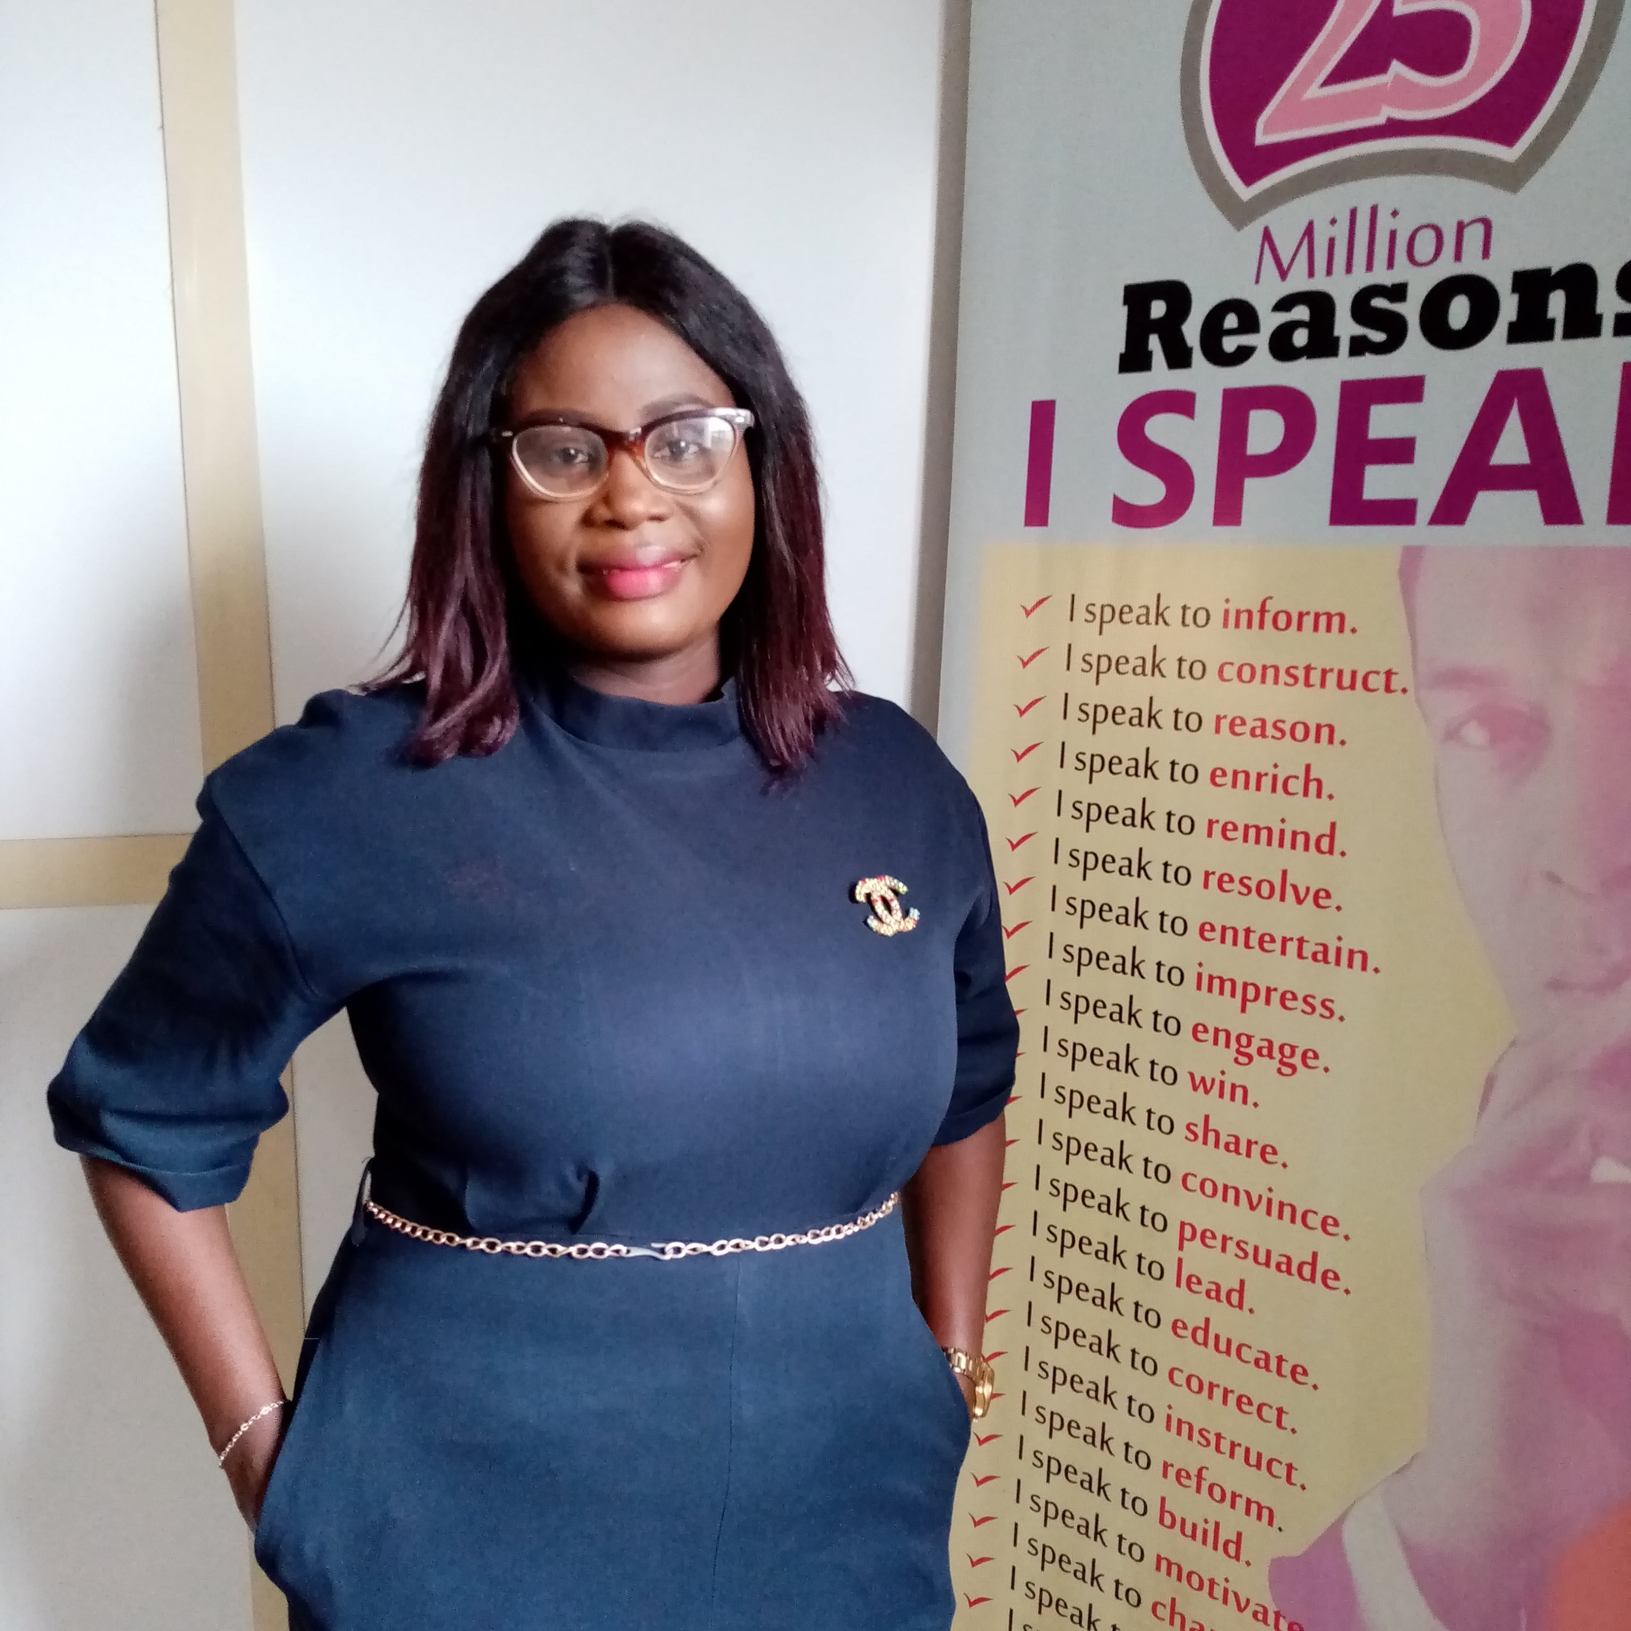

D.O.B: 22nd November 1988
Nationality: Nigerian

1, Ishola Street,
Captain Bus-Stop,
Ekoro Road,
Abule-Egba,
Lagos.
+234-8136906929
taiwoanifox@gmail.com

PROFILE
CONTACT
TEFL qualified teacher with four years teaching experience,teaching students from the ages of five to fifteen in a variety of contexts including an online Diction/Public Speaking monthly summer boot camp.

TEACHING EXPERIENCE
DECEMBER 2019 – MARCH 2020
TEFL TEACHER
Institute of Certified Communicators
Lagos City, Nigeria.

JANUARY 2021 – PRESENT
DICTION/PHONETICS FACILITATOR
ES Basics Diction and Social Polish Academy.
Lagos City,Nigeria.

- Teaching students Phonics/Diction-In-English from ages five to fifteen
- Attending professional development input sessions
- Teaching intensive and extensive courses
- Use a variety of resources
- Experience with interactive whiteboards
- Extra curriculum activities, e.g Spelling,Public Speaking competition.
- Teaching in a summer school environment
- Planning, designing and delivering lesson plans
Experience with classroom management
- Organizing teachers’ training
TAIWO ANIFOWOSE

MARCH 2022 – APRIL 2022
Teacher Record TEFL course
United Kingdom

MARCH

REFERENCES
MOBILITY
Full clean Nigeria driver’s license
HOBBIES
Teaching, reading ,baking and cooking
Available upon request
Native English
Basic French
Proficient in using Microsoft Word, Microsoft PowerPoint, ZOOM.
COMPUTER SKILLS
LANGUAGES

- Facilitating Spelling Bee competition for learners in a Spelling Bee Club

DECEMBER 2020 – MARCH 2022
Tuteria Spelling Bee Facilitator
PERSONAL DEVELOPMENT
EDUCATION

Bachelor (Agriculture) Technology.
B.Agric(Tech)

120 Hour Combined TEFL Course: PASS
- 120-Hour TEFL Course
- 40-Hour Teaching Online
- 30-Hour Lesson Planning

COURSERA ENGLISH FOR CAREER DEVELOPMENT: PASS(95.84%)
NOVEMBER 2005 – JUNE 2011
Federal University of Technology Akure.
Ondo State.
Nigeria.

