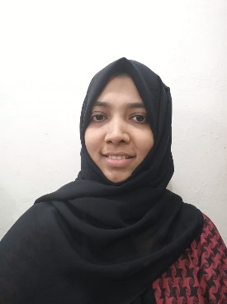

BHAFA EMAIL: bhafa786@gmail.com Mob: +965 97261332

|  |  |  |
| --- | --- | --- |
| **CAREER OBJECTIVE**   * Seeking an opportunity to use my knowledge and talent to educate children and make them ready for todays world.   **PROFESSIONAL QUALITIES**   * Comprehensive problem-solving abilities * Willingness to take responsibilities. * Creative flair * Attention to details * Goals oriented * Time management * Good communication and inter personal skills * Flexibility   **LANGUAGES KNOWN**  English, Hindi, Malayalam |  | **EDUCATION:**  **Graduation:**  2007 -2011 Bachelor’s degree in Electronics and Communication Engineering (B Tech) from Sambhram Institute of technology, Bangalore, India.  **Higher Secondary School:**  2005 – 2007 Higher Secondary Education from St’ Anne’s PU College, Bangalore, India.  **EXPERIENCE:**   * **Pakistani school, Kuwait. (2018 – 2020)**   **RESPONSIBILITIES:**   * Preparing lesson plans for the students and developing assignments for the students. * Discussing the progress and needs of the students with the parents in the weekly meetings. * Attending teachers training workshops. * Preparing visual aids for the students and organizing classroom discussions on the topics related to the lessons. * Evaluating the performance of the students and maintaining the records of the students. * **Metro Medical care, Farwaniya (Kuwait)**(June 2016-Oct 2018) * Insurance data work. * Handling calls, customer service and other paper works. * **Bharath Electronics Ltd(Bangalore)**   Project Engineer.  11 Jan 2011 – 10 Feb 2012   * Preparation of requisite documents for testing and trouble shooting for all in-house and sub contracted modules * Updating project status to superiors. * Effective utilization of in-house facilities and available resources. * Assigning priorities to different activities based on project completion date with the help of production planning department. * Handling all aspects and activities of a project as a project engineer.     I hereby declare that the above furnished details are correct to the best of my knowledge.  **Place**: Kuwait BHAFA **Date**: |