*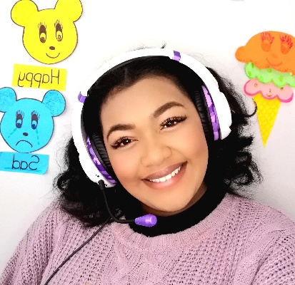Resume of Shanice Miles*

***Personal Details***

First name :Shanice

Surname :Miles

Email :mshanice649@gmail.com

Phone :078 832 0623

Country :South Africa

City :Cape Town

Nationality :South African

Date of Birth :26 August 2000

Languages :English (Native)

***Education***

Matric at Strand Secondary School (2015-2018)

TEFL Universal – 120 hour TEFL certificate (2022)

N6 level Education at Bellview Academy (2020-2022)

Passionate and effective TEFL Teacher with experience helping students to improve their English language vocabulary, reading comprehension and writing. Adept in all aspects of activities in the four areas of language learning: Speaking, Writing, Reading, and Listening. Bringing forth several years of experience, combined with a passion for serving as an effective educator and helping students to achieve proficiency in the English Language.

***Skills***

* Communication skills
* Fast learner
* Lesson planning
* Lesson modification
* Differentiation Techniques
* Language building skills

