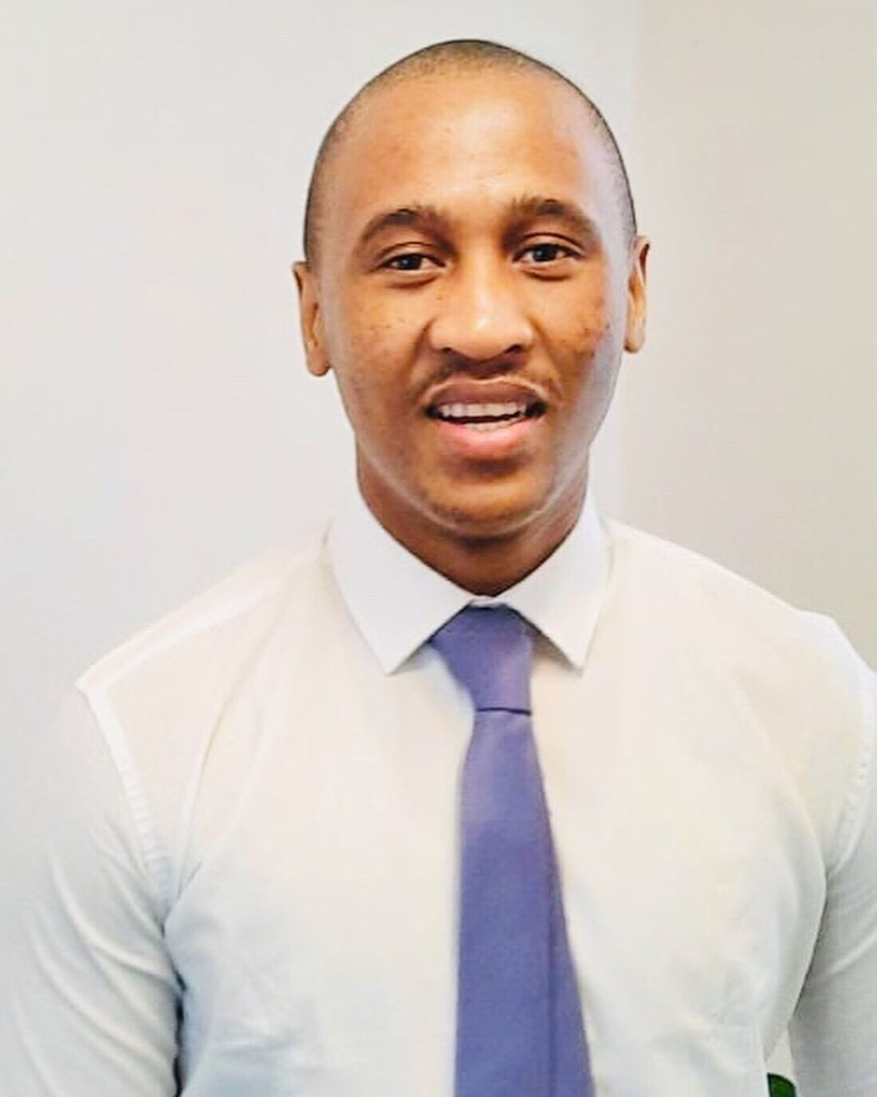 |  | CV  Lloyd McDonald Sizwe Jacobs
Profile  A dedicated team player, very competent in dealing with practical issues and providing solutions for work-related problems. I possess excellent communication skills, problem-finding, and solving skills, and the ability to prioritize workloads to meet deadlines. I can adapt quickly to new environments and although I have experience in Human resources Administration and Construction.  Contact  PHONE:  071 373 2077  076 435 4519  Email:  Lloydjacobs2000@gmail.com  SKILLS & COMPETENCIES  • Personal Skills: Strong Leadership Skills (Decision Making, Strategic Thinking, and Acting), Business Awareness,  Ideation, Administrative Skill, Time Management; Problem-solving skills & Relationship building.  • Communication Skills: Excellent interpersonal, group facilitation & public speaking.  • Driver’s Licence: Clean Code 10  • Skill: Proficient use of MS Office Suite (Word, Excel, PowerPoint), |  | EDUCATION  Lee Rand Secondary  Completed Matric - 2012  Istanbul Sabahattin Ziam University (Turkey)  MBA (Master of Business Administration)  2022  University of South Africa  BCom Accounting and Internal Auditing  2022 - current  WORK EXPERIENCE  Protea Hotel Central - Banqueting and Bar  January 2012 – December 2013 Part Time  - Prepare coffee breaks, carts, and stations with appropriate food and beverages as stated in Banquet Event Order.  - Delivering Alcoholic and Non-alcoholic drinks for service to your customer’s table.  - Take beverage orders and collect payments where specified.  - Remove China, glassware, silverware, etc. from tables at the conclusion of the meal period and deliver to the stewarding area.  - For defective minibars, issuing a Malfunction Request Slip and notifying the technical service, etc. performs duties and operations.  - Preparing the mini bar cart for service  - Checking the mini bars in the rooms, to complete the deficiencies and process them for the customer’s account,  - To clean the minibars.  - In case the customer leaves the hotel, check the mini-bar in his room and notify the reception of the consumed food and drinks, f ) Fill the minibar list prepared for each room and report Cost-Control.  Edgars Store- Sales Consultant December Casual  December 2013 – March 2014 Part time  - Ensuring that the sales departmental targets are achieved  - Providing customers service  - Merchandising of stock  - Managing stock losses  - Housekeeping  Free State Department of Education- Personal Assistant  March 2014 – December 2014 Part-Time (Volunteering)  - Schedule meetings and manage calendars.  - Answer phone calls and emails and take messages.  - Take accurate and comprehensive notes at the meeting.  - Schedule meetings and manage calendars.  - Answer phone calls and emails and take messages.  - Take accurate and comprehensive notes at meetings.  - Schedule meetings and manage calendars.  - Answer phone calls and emails and take messages.  - Take accurate and comprehensive notes at the meeting.  Central University of Technology – Computer Lab Student  March 2015 - September 2015 Part Time  - Assisting Students with Computers.  - Maintain the Computer Lab.  Motheo TVET College Hillside View Campus - Admin Clerk  January 2016 – November 2016  - Managing the Switchboard  - Capturing Data (Microsoft Word, Excel).  - Scheduling Meetings and welcoming visitors.  Liviero Construction – Assistant Safety Officer  Nov 2017- Sep 2018 11 months  Central University of Technology – Bloemfontein  - Perform daily site inspections  - A Report accidents, unsafe conditions, and unsafe acts to the superintendent.  - Attend, participate/or facilitate safety meetings including Safety Committee meetings and Toolbox Meetings.  - Raising health and safety awareness and reporting on key issues.  - Intervene in unsafe activities.  Istanbul Sabahattin Ziam Üniversitesi  March 2020 – April 12 months  - Assistant Deputy Coordinator, International Office  - Handle inquiries from students, visitors and parents from outside Istanbul, Turkey.  - Deal with inquiries from university staff regarding international students.  - Process and evaluate applications from potential students and exchange students.  - Organize events for international students.  - Assist with visa inquiries, such as extensions or deadlines  - Operate a ‘Student drop-in’ center for international students  - Support international students throughout their period of study  - Coordinating exchange programs with countries across the world.  - Promote the university by visiting other countries  - Attend international exhibitions and meetings as a university representative  - Organize orientation days for new international students  Facilitate the arrival of new students (information and advice before arrival.  Synergy HR Consulting - HR Officer  June 2021 - Current  - Contract of employment  - Job descriptions  - Sick Leave Policy  - First Aid Training  - Occupational Injuries diseases and social media policy  References  Available upon request

