nokuthula majola  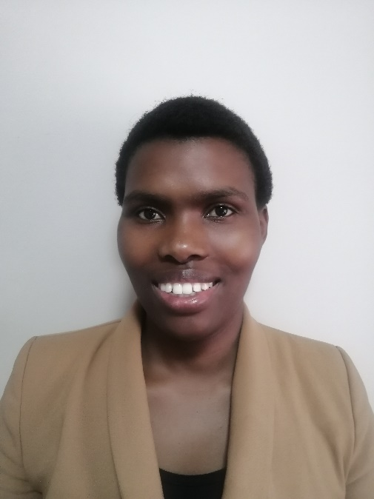  np2dladla@gmail.com  +2761 489 0327  ABOUT ME  Responsible qualified teacher, passionate about delivering outstanding quality service. I have 3 years of teaching experience. I have a degree in accounting. I enjoy using my creativity to produce stimulating lessons to inspire and engage a class. I work well in a team and can communicate effectively at all levels and ages.  HOBBIES  Spending time with my son playing new activities and games together.  PERSONAL DETAILS  DATE OF BIRTH: 12 July 1993  MARITAL STATUS: Married  NATIONALITY: South Africa  DRIVING LICENCE: Yes  LANGUAGES SPOKEN: English  REFEREES:  1. Name: Joshua Pretorius  Contact number: +2774 185 4730  Company: Global Load Control  Position: Team Leader  2. Name: Makhosi Mkhwanazi  Contact number: +2779 442 1545  Company: Damelin College  Position: Academic Manager | Experience  01/2016 – 12/2016  Damelin College – Durban South Africa  Lecturer  - Planning teaching, including lectures, seminars/tutorials and learning materials  - Meeting students individually to discuss progress  - Checking and assessing students' work  - Pursuing research  - Interviewing potential students  - Carrying out administration, such as attending faculty meetings and writing reports  - Writing research proposals, papers and other publications  - Supervising PhD students and research staff  - Managing research budgets  - Preparing bids for funding for departmental research projects.  02/2013 – 12/2014  University of Zululand – Empangeni South Africa  Tutor  - Providing academic support and assistance to accounting students.  - Teaching students essential accounting and financial concepts.  - Meet students on a one-on-one tutoring session.  - Assisting students with projects and helping them master Microsoft Excel.  - Guiding students as they become a full-time accountant and maintaining records of every student I tutor.  - Motivate students and inspire them to study and improve their academic knowledge.  - Design and implement lesson plans based on a student’s needs.  TEFL TRAINING  Level 5 168 Hour TEFL Certificate – The TEFL Academy, UK.  - April 2022 – September 2022  - Created lessons for a variety of levels from pre-intermediate to advanced  - Teaching speaking, listening, reading and writing  - Material & resource creation, utilizing the internet  - English grammar and how to teach the essential language  - Needs analysis and teaching in different situations  - Classroom management and teaching techniques  Education  2020  University of south africa (unisa)  Advance Diploma: Accounting Science  Financial Accounting, Financial Management, Management Accounting, Taxation, Auditing  2014  UNIVERSITY OF ZULULAND (UNIZUL)  Bachelor of Commerce: Accounting  Financial Accounting, Financial Management, Management Accounting, Taxation, Auditing

