Curriculum Vitae of Cameron Wilke

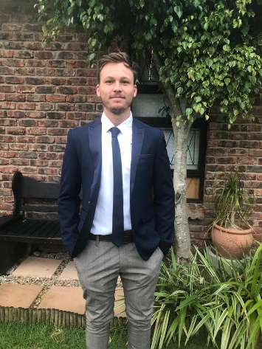

Name: Cameron

Surname: Wilke

DOB: 29 September 1999

ID Number: 9909295180080

Gender: Male

Nationality: South African

Postal Address: 11 Eddie Muller Street

Kamma Park

Gqeberha

6070

Contact Information: Cell: 060 526 9348

Email: cameronwilke2@gmail.com

Criminal Record: None

Computer Literacy: PowerPoint

Word

Excel

SACE: Applied and Pending

PDP: Applied and Pending

**Education and Qualifications**

1. **Grey High School**

Qualification: Bachelors’ Pass

Year: 2017

Subjects: English Home Language

Afrikaans Second Language

Mathematics

History

Geography

Business

1. **Nelson Mandela University**

Degree: Bachelor of Arts Degree in

English

Psychology

Year of Entry: 2018

Postgrad: Post Graduate Certificate on Education

FET in English and History

Year of Entry: 2021

Student Number: 219200602

**Awards, Achievements and Leadership**

* Grey Matter Committee Member: 2015-2017
* Team Award for Rowing: 2015
* Half Colours for Rowing: 2016
* Student Cadet Officer (SO): 2017
* NMU Men’s Rowing Captain: 2018 – 2019
* NMU Rowing Club Chairman: 2019 – 2020
* Eastern Cape Rowing Association Secretary: 2018 – 2022
* Post-graduate Merit Bursary: 2021

**Sports**

* Rugby: 2013-2016
* Rowing: 2013-2022

**Languages**

* First Language: English
* Second Language: Afrikaans

**Current Employment**

* Grey High School Rowing Coach: 2018-2022
* Substitute at Grey Junior School on a regular basis for grades 6 – 7.

**Attributes and Capabilities**

I have the following strong attributes and Capabilities:

* My degree has provided me with opportunities to think creatively about different teaching methods and how to successfully apply them.
* My communication skills are excellent and clear.
* I am innovative, pro-active and value good planning.
* I value a strong body and a healthy mind, with lots of active participation in both the classroom and sports fields.
* Thanks to my experience within various jobs, I can withstand pressurized situations with positive solutions.
* My strongest abilities lie with my social skills, where I am able to command the attention of a classroom of students and use my enthusiasm for what I teach to catch their attention to the topic.

**Experiences**

* Due to my year of practical I have experience in teaching English to senior students in Grades 10-12.
* For the past year I have substituted at Grey Junior school for grades 4 – 7. Covering a number of subjects such as English, History, Mathematics and Natural Sciences.
* I have worked, part-time, as a waiter as well as a delivery driver for Executive Caterers.
* My time as a rowing coach has provided me with the necessary skills to educate many students in an outdoor environment.
* I have been able to attend many sporting tours that have made me responsible for the safety and wellbeing of students for an extended period.
* As secretary of the Eastern Cape Rowing association, I have learnt a vast amount of admin skills such as: creating meeting agendas and minutes, emailing, and keeping track of daily activities.
* During my time as Captain, I have learnt to motivate others and work towards a common goal.
* As Chairman of the NMU Rowing Club I have learnt to delegate tasks and lead group tasks.

**References**

Johnathon Van Niekerk (Mentor Teacher)

0848231223

Reinhardt Oborn (Head Rowing Coach)

0834125256