Breskic teodora  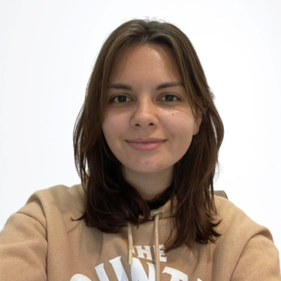  teodora.breskic18@gmail.com  +38268606733  ABOUT ME  I am degree-educated, qualified EFL teacher. I enjoy using my creativity to produce stimulating lessons to inspire and engage a class. I work well in a team and can communicate effectively at all levels and ages. Currently, I am employed at Native Camp, where I give online classes to kids and adults.  HOBBIES  Reading books  Cooking  Taking photos  PERSONAL DETAILS  DATE OF BIRTH: 18.09.2000  MARITAL STATUS: never married  NATIONALITY: Montenegrin  DRIVING LICENCE:  LANGUAGES SPOKEN: English  IT SKILLS:  Microsoft Word (advanced)  Microsoft Power Point (advanced) | Experience  Luka Bar AD  Working at an informational desk and providing tourists with useful information.  Giving classes to kids in the neighbourhood  https://nativecamp.net/waiting/detail/98829/1  TEFL TRAINING  Level 5 168 Hour TEFL Certificate – The TEFL Academy, UK.  - July 2022 – December 2022  - Created lessons for a variety of levels from pre-intermediate to advanced  - Teaching speaking, listening, reading and writing  - Material & resource creation, utilising the internet  - English grammar and how to teach the essential language  - Needs analysis and teaching in different situations  - Classroom management and teaching techniques  Education  Degree / Date Earned  School  University of Montenegro Faculty of Philology, Niksic  English language and literature BA  September 2019-September 2022

EMPLOYMENT
- English Teacher at Native Camp (November 2022)
- Travel Manager at Parus( Bar, MNE) (Jun 2020-September 2020)
- Travel Manager at Turisticka agencija Sutomore (Sutomore, MNE) (Jun2019-Septemebr 2019)

Skills:
Decision Making, fast learner, teamwork, creativity, adaptability, communication skills, computer skills, problem solving

