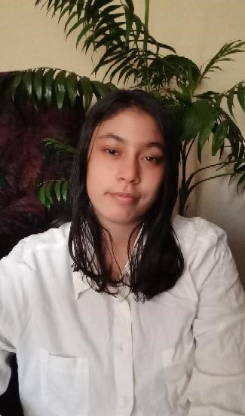**KAUTHAR BUTTON**

TEFL CERTIFIED ESL TEACHER

D.O.B: **13 November 2002**

Nationality: **South African**

D10 Albow Gardens

Rugby

Cape Town

South Africa

+27 815208533

[kautharbutton@gmail.com](mailto:kautharbutton@gmail.com)

**PROFILE**

**CONTACT**

TEFL qualified teacher with experience in providing tutoring to disadvantaged youth in marginalised South African communities, where educational camps and academy’s are out of reach and non – existent.

**Objective Overview**

It is with great enthusiasm that I submit my resume for your consideration to enter the formal and professional faculty of teaching English abroad. As a young South African female living in a country where education is a privilege I am confident in my ability to become a valuable member of your teaching team.

Being TEFL certified has created the opportunity to broaden my own horizons and pursue my dreams in seeking an English teaching position in Thailand, South Korea or Japan. Whilst I am with no formal teaching experience at present what I do have is the passion, vision, drive, stamina and patience to meet any pre requisite the post might entail to ensure that students young and old not only grasp the English language but learn to appreciate the advantage thereof.

In truth, I really enjoy immersing myself in the language, lifestyle, and traditions of other cultures. Nelson Mandela once said: “A good head and good heart are always a formidable combination. But when you add to that a literate tongue or pen, then you have something very special.” I have dedicated most of my youth imparting this message to our youth and it is now time for me to see the world not as it is but how it should be.

I believe that being given the opportunity to teach in your country will not only allow me the benefit of teaching and empowering your students but afford me the chance to learn from your students as well, this is the essence of a great teacher.

Kauthar Button

**Kauthar Button**

Cooking- relaxes me

Reading- keeps me informed

**JUNE 2016 – Ongoing**

Creator of MAD Group (making a difference)

Community based work projects.

*Cape Town, South Africa*

* Volunteer Reading Program to Red Cross Hospital.
* Mentoring and empowering youth in disadvantaged communities through tutoring.
* Distributing food and clothes to needy
* Anti Drug and Crime campaigns.
* Assisting struggling youth and adults with reading and writing in impoverished communities.

**Dec 2021 – NSC**

Matriculated with diploma

Ned Doman Secondary School

*Cape Town, South Africa*

Native English

Native Afrikaans

* RCL – Representative Council For Learners
* RCL - Chairperson
* Agricultural Chairperson
* School library Assistant
* Water works Ambassador Program
* Debate Team

**REFERENCES**

**MOBILITY**

**HOBBIES**

Attached references and more available on request

Sufficient in using Microsoft Office, SMART board software

**COMPUTER SKILLS**

**LANGUAGES**

**Jan 2016- Dec 2021**

School Tenor

*Cape Town, South Africa*

**PERSONAL DEVELOPMENT**

**EDUCATION**

**180 Hour TEFL Course: pass**

**Nov 2021 – Certified TEFL**

I-to-i

*Online*

**Feb 2022- Current Employment**

Welcome Primary School

3rd Street, Welcome Estate

Athlone, Cape Town, South Africa

Tel: +27 216374201

Email admin@welcomeps.wcape.school.za

**Dec 2022 – Diploma obtained**

Alison

Online

**LSE (Learner Support Educator)**

**Teach Literacy Program based on CAPs system**

**Classes- Grade 6 and 7’s**

**36 Students per class**

**Lesson Plans**

**Ref: Mr Jacobs +27 644060898**

**Diploma in Psychology**