* Curriculum Vitae of :

AMBROZA MONIQUE VAN ROOI

Personal information

|  |  |
| --- | --- |
| Surname | : Van Rooi |
| First name | : Ambroza Monique |
| Identity number | : 0309270731081 |
| Nationality | : South African |
| Address | : 12 Arundel Court  : Lavender Hill |
| Contact details | : 0712118867 |
| Dependants | : None |
| Marital status | : Single |

Academic Results

School Attended : Crestway High School

Highest Grade : Grade 12

Subjects : Afrikaans, English

: Math Literacy, History

: Consumer studies

: Geography

: Life Orientation

Goals and Aspirations

As a highly motivated person who has always been involved in a range of activities, I have developed a responsibility and mature approach to any task. I undertake reliable and pro-active with good communication skills verbal and in writing and also developed excellent organisational skills with a strong capacity to improve quality and performance standards within structures.

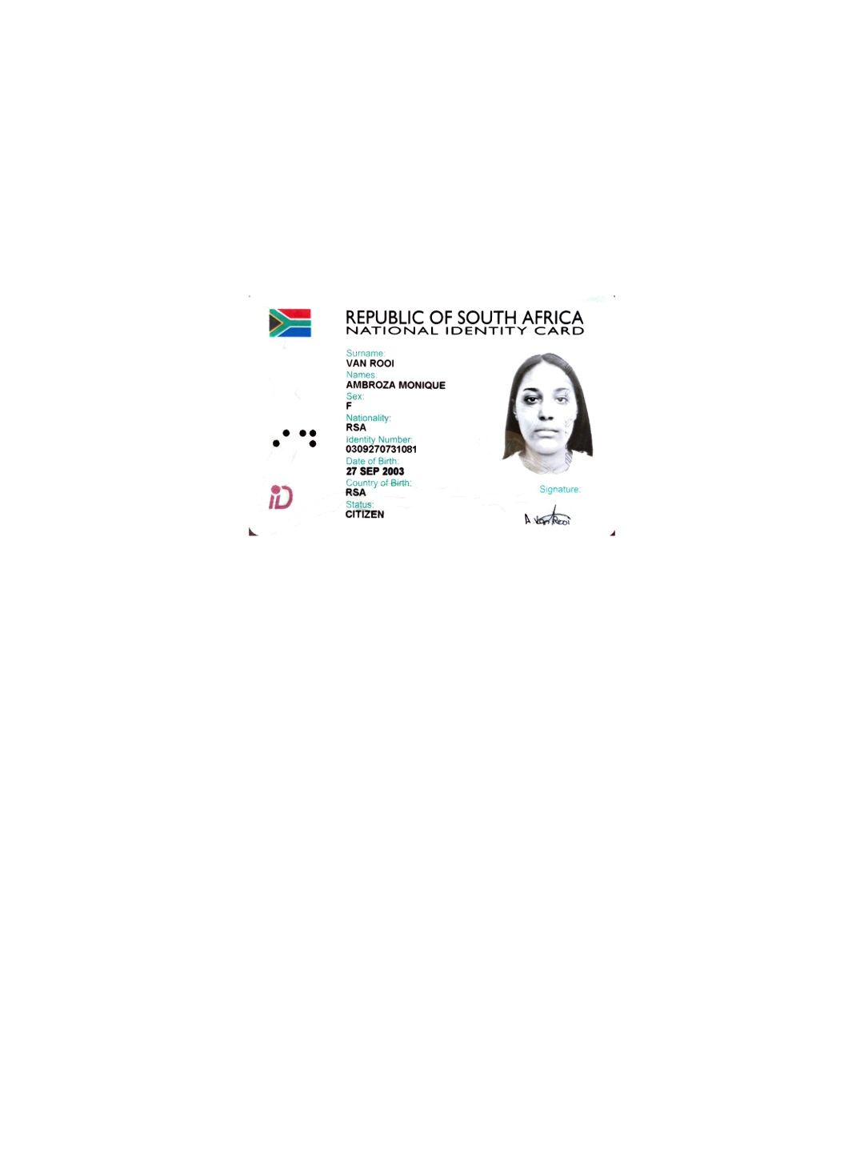 ù

