Tim Jenkins  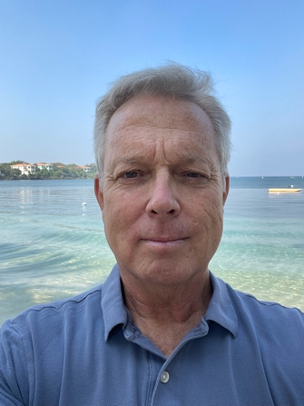  Timothy.rae.jenkins@gmail.com  1-902-832-3052  ABOUT ME  I am very open minded, eager to learn, and flexible In my approach to life. I enjoy using current events to bring the classroom to life, and make the subject material a personal experience.  HOBBIES  I enjoy spending my free time outdoors, surfing, scuba diving, skiing, fishing, hiking and camping. I am also a student of Tae kwon-Do  PERSONAL DETAILS  DATE OF BIRTH: May 12, 1965  MARITAL STATUS: Married  NATIONALITY: Canadian  LANGUAGES SPOKEN: English  REFEREES:  Kim Buckler, Senior Trust Officer  Office of the Public Trustee,  Halifax, NS  Canada  1-902-424-7760  Paul McAdam  Life Long Friend  Fredericton, NB  Canada  1-506-260-2576 | Experience  Recently retired, I decided to rekindle an Interest I had In my youth to teach english as a foreign language. I decided to volunteer as a tutor at the Multicultural Association of Fredericton, NB. I have found the experience to be quite fulfilling, and so I have pursued the matter further by completing my TEFL training with the TEFL Academy.  I hope to use this training to secure employment as a teacher of english as a foreign language.  TEFL TRAINING  Level 5 168 Hour TEFL Certificate – The TEFL Academy, UK.  - December 2022 – March 2023  - Grade - Pass  - Created lessons for a variety of levels from pre-intermediate to advanced  - Teaching speaking, listening, reading and writing  - Material & resource creation, utilizing the internet  - English grammar and how to teach the essential language  - Needs analysis and teaching in different situations  - Classroom management and teaching techniques  Education  1990 Bachelor of Arts - First Class Honors  Political Science with Specialization In  International Relations  University of New Brunswick

EMPLOYMENT
I started my career In financial services In Vancouver, BC, In the summer of 1990. After our first child was born In 1993, we decided to return to New Brunswick, to be closer to our family. Luckily, I was able to secure a position with my then current employer in the new location. After a few years in New Brunswick, I was transferred to Halifax, Nova Scotia, Canada, where we lived for 25 years. Now that our children have grown and moved on, we decided to downsize and seek new opportunities. What follows is a summary of my career.

Nova Scotia Public Trustee – Trust Officer April 2007 – May 2022

Responsible for the comprehensive financial management of incompetent adults admitted to health care system and nursing homes. Included the management and sale of real property, investments, insurance, banking, debt management, and taxation.

Bank of Nova Scotia Trust Company – Trust Officer 2002 – 2007

Responsible for the administration of estate, trust and investment agency accounts, and managing client relationships.

TD Asset Management – Regional Sales Manager 1999 – 2001

Responsible for training staff in TD Canada Trust branches located in Atlantic Canada. Presented national and regional initiatives to staff members and hosted, presented and facilitated customer seminars.

TD Bank – Financial Advisor 1997 – 1999

Responsible for advising clients with respect to the full range of financial products.

TD Trust – Trust Officer 1990 – 1997

Administration of estate, trust and investment agency accounts, and managing client relationships.

