Florencia aranda agostini  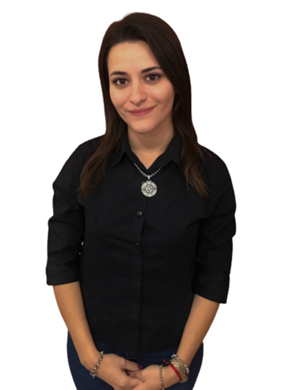  florciaranda@gmail.com  +5493425036067  ABOUT ME  I am a degree educated, soon to be qualified EFL teacher. I enjoy using my creativity to produce stimulating lessons to inspire and engage a class. I work perfectly well in a team and can communicate effectively at all levels and ages.  HOBBIES  I love reading drama and mystery books. Also, I like playing tennis in my free time.  PERSONAL DETAILS  DATE OF BIRTH: 16th May, 1994  MARITAL STATUS: Single  NATIONALITY: Argentinian  DRIVING LICENCE: B1  LANGUAGES SPOKEN: Spanish  REFEREES:  Camford Institute: +5493425430682  Guzmán-Fosco Language Academy: +5493425103584 | Experience  Since 2019 I have been working with children, teens and adults in in-person and online contexts. I have learnt that each age group has different needs and challenges to overcome. That’s why, as a teacher, I try to be creative and personalise my lessons accordingly. I enjoy working with kids the most. But I’m still enthusiastic about older students.  TEFL TRAINING  Level 5 168 Hour TEFL Certificate – The TEFL Academy, UK.  - October 2022 – March 2023  - Grade pass  - Created lessons for a variety of levels from pre-intermediate to advanced  - Teaching speaking, listening, reading and writing  - Material & resource creation, utilising the internet  - English grammar and how to teach the essential language  - Needs analysis and teaching in different situations  - Classroom management and teaching techniques  education  english teacher/ march 2023  Instituto Superior del Profesorado de Ingles Nro. 1 - Estela Guinle de Cervera – Santa Fe, Argentina.  GPA for primary level 7.88/ GPA teaching practice 8.8  GPA for secondary level 7.78/ GPA teaching practice 8.6

EMPLOYMENT
- Teacher assistant (primary level) at private school “Colegio Dante Alighieri” in Santa Fe, Argentina [26/03/19 - 04/ 07-19]
- English teacher (primary and secondary level) at private institute “The English Lab” in Santa Fe, Argentina [01/03/21 – 22/09/21]
- English teacher (primary and secondary level/ Adults) at private institute “Instituto Camford” in Santa Fe, Argentina [07/03/22 – 15/12/22]
- English teacher (primary and secondary level/ Adults) at private language academy “Academia Guzmán-Fosco” in Santa Fe, Argentina [13/03/23 – present].

