Bianca Venter  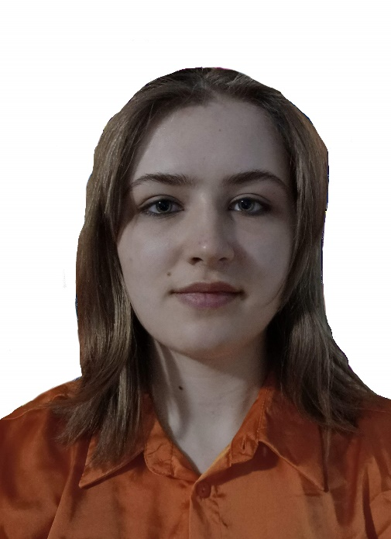  bianci.venter@gmail.com  +26 63 188 6753  Link to other online properties: Portfolio/Website/Blog  ABOUT ME  I am a degree educated, and a qualified EFL teacher. I enjoy using my creativity to produce stimulating lessons to inspire and engage a class. I work well in a team and can communicate effectively at all levels and ages.  I am an active listener, problem solver and have a sunny disposition  HOBBIES  - -Reading  - -Writing  - -Drawing  - -Playing guitar  - -Playing guitar  - -Learning new languages  PERSONAL DETAILS  DATE OF BIRTH: 2000/12/07  MARITAL STATUS: Unmarried  NATIONALITY: South African  DRIVING LICENCE: Valid code B license  LANGUAGES SPOKEN:  - Afrikaans  - English  REFEREES:  Yolandi Myburg – 081 525 8172 | Experience  - Completed a 2-week internship at Mustard production  - Volunteered at a kindergarten in 2021  TEFL TRAINING  Level 5 168 Hour TEFL Certificate – The TEFL Academy, UK.  - March 2023 – April 2023  - Grade  - Created lessons for a variety of levels from pre-intermediate to advanced  - Teaching speaking, listening, reading and writing  - Material & resource creation, utilizing the internet  - English grammar and how to teach the essential language  - Needs analysis and teaching in different situations  - Classroom management and teaching techniques  Education  Diploma in digital animation - 2022  The animation school

