Profile  - English Teacher  - Professional ballet dancer  - R.N  Contact  PHONE:  972-545315376  EMAIL:  Yisrael0509@gmail.com  isev@walla.com  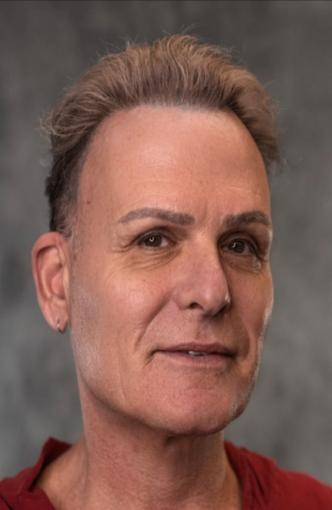 |  | Yisrael oOLY sANDLER  EDUCATION  2021-TEFL / TESOL certification (ITTT 00316256)  2017- ME.D - Bilingual Education in Multi-Cultural Society.  Studied in English/Hebrew realm.  Lewinsky College, Tel Aviv, Israel.  2010 -Teaching Certificate Specializing in English,  Lewinsky College, Israel.  2005 -BE.D in Education, Seminar Kibbutzim college, Tel Aviv, Israel.  Nursing Studies  1980-1984 - studies in Bar Ilan University & Hasharon hospital Israel.  Artistic Experience  1979-1997 – Professional ballet dancer in Israel and five years in USA.  Nursing Experience  1984- 1990- Hospice Care, Tel Hashomer Hospital, Israel.  1999-2004 – Operation Room, Assuta hospital, Israel.  Teaching experience  1998 – 2004 - Dance instructor in the Israeli Ministry of Education.  2005-2008- English teacher in primary school, Matan settlement.  2008-2009- English teacher in Nachshonim primary school Ariel Settlement.  2009-2010- English teacher in BarTov primary school Ranana.  2010-2012- English teacher in Givat Zeev, Jerusalem primary school.  2012-2015- English teacher Denmark high school, Jerusalem. (High Risk Juvenile).  2015-2017- English teacher Tichonet Alterman high school, Tel –Aviv.  2017- 2019 -English teacher Ashalom - Rabin High school, Mitzpe Ramon.  2019 – 2021-English teacher Emek Hulla high school Kfar Bloom.  2021-2022 –Hebrew teacher in SJCS Seattle WA, USA.  2022 –2023 –English teacher Tichonet Alterman High school Tel Aviv .  AdDiTIonal information
MILITARY SERVICE
1977-1980 – I.D.F service (Air Force).
English –fluent
Hebrew –Native speaker

