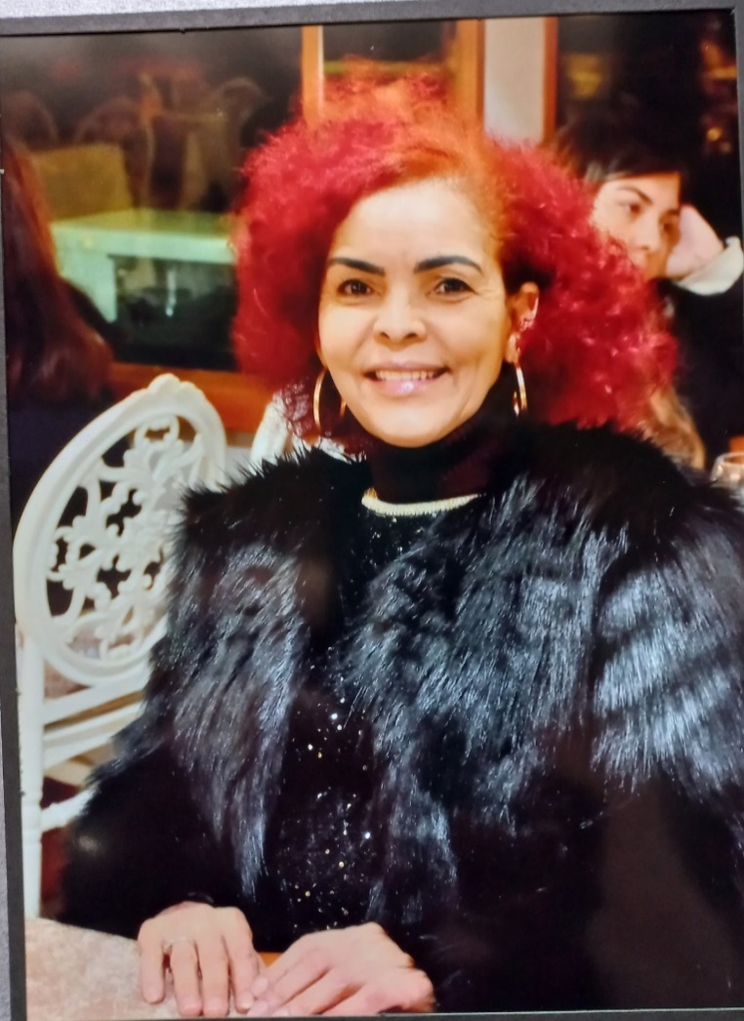
Jane M.C. Mekoa
South African, native English-speaking teacher, with 20 years of experience teaching English and other core subjects at the upper Primary and Junior Secondary levels. One of my best traits is to instill a positive attitude in learners towards learning, in all aspects and once this is done, students try their best. Strongly committed to ensuring every student reaches their optimum potential and that no student of mine is left behind, as I use various and creative methods in my lesson plans, as well as in both my summative and formative assessments.
I am confident that I would contribute effectively to your team. Reflective, responsive and resilient, catering for differentiation and inclusivity in lessons. I ensure the learners are aware of the objective of the lesson and what is expected from them. A collaborative person and enjoy learning and sharing with my colleagues and the school public.
Contact: +27 840 741 125 Email: jane_mekoa@yahoo.co.uk / janemekoa1@gmail.com
Nationality: SOUTH AFRICAN Current Location: Durban, South Africa
ACHIEVEMENTS

- Initiated and taught a Social Studies programme for expatriate earners at Sohar International, whilst the nationals attended their compulsory subject classes.
- Co-ordinated and implemented an Environment Club, with support of local solid waste centre. Awarded best school environment in the district. Vegetables from our gardens donated to local children’s orphanage.
- Reading Club for whole school
- Passed Cum Laude (Honour’s Degree), whilst teaching full time and attending lectures full time (evenings).
.
SKILLS
- Creative Lesson Planning and Implementation  - Differentiated learning methods and inclusivity  - Experiential, Anecdotal and Realistic Learning  - Organize and promote an inspiring, purposeful and safe learning environment  - Classroom Management and Discipline strategies  - Differentiated and various methods of formative and summative assessments. | - Organized Record Keeping  - Collaboration and co-operation  - Follow school policy  - Integration of subject across the curriculum  - Identifying different abilities and providing remedial intervention, where necessary.  - Positive Motivation.  - Communication with management, parents and the school public.  - Flexible and spontaneous  - Reflective, responsive and resilient, allowing me to meet and overcome challenges.

PROFESSIONAL EXPERIENCE

04/2023 – Present - Social Studies / Humanities (Grades 7 – 9) E.S.I. Cambridge
Boutique School, SOUTH AFRICA
Reason for leaving: Director always knew I will apply to teach abroad.

09/2021 - 08/2022 - English, Maths, Science, Social Studies (Grade 6) British School
Benghazi, LIBYA
Reason for leaving: Did not complete 2-year contract to take care of my terminally ill mom.

09/2013 – 06/2021 - History, Biology, English (Grades 8 – 10) Wentworth Secondary, S.A
Reason for leaving: To enhance and broaden my international experiences.

08/2011 – 07/2013 - English (Grade 4, 5 and 6), Sohar International School, Oman
Reason for leaving: Relocated back home, whilst my girls studied at tertiary institutions.

01/2009 –12/2010 - Studied towards a master’s degree, as I was in a motor vehicle accident, and could not work for a while, thus studied whilst recuperating.

08/2006 – 07/2008 - English and Social Studies (Grades 5 -7), Sohar International, Oman

01/1989 – 06/2006 English, History and Life Orientation (Grades 8 – 10) Wentworth Secondary, South Africa
Reason for leaving: International educational experience.
QUALIFICATIONS
Jan 2009 – Dec. 2010  Bachelor’s degree in education (Masters) – INCOMPLETE. ALL COURSEWORK completed.  2005 – 2005  Bachelor’s degree in education (Honours) Cum Laude  University of Kwa Zulu Natal, Durban, South Africa | 2004 – 2004  Advanced Certificate in Education  University of Kwa Zulu Natal, Durban, South Africa  1986 –1988  Diploma in Education (Senior Primary)  Bechet College of Education, Durban, Kwa Zulu Natal, South Africa

INTERESTS
CPD Courses attended, and skills developed.
Professional Development and ever-changing curriculum training, Life Coaching

Extra-curricular
Book Club, Life Skills, Environmental Issues, Presentations and Debates, Baker (basic safe recipes)

Personal Interests
Reading (avid reader), Research, Socializing, Lifelong Learning, Walking
REFEREES

Name: Mr Rishen Pillay (Director)  School: E.S.I. School (Educational Style Integration), Cambridge, South Africa  Contact: +27 7965 85983  Email: hello@esi-school.co.za  Rishen.pillay1@gmail.com | Name: Miss Nicolette Catelle (Deputy Principal)  School: Wentworth Secondary, South Africa  Contact: +27(31) 468 2039 school  Mobile: +27 83 400 2403  Email: nicolette.catelle@gmail.com
Name: Mr. Thabo Ngomo (Ex -Head, moved to  Saudi Arabia  School: British School Benghazi, LIBYA  Contact: +966 562 138 230  Email: Tmngoma@fis.edu.sa | Name: Mr P. Ramburan (Ex - Head of English and  Deputy Principal)  School: Sohar International, Sohar, OMAN  Contact: +968 267 508 62 school  Mobile: +96897314173  Email: futurescienceschool@gmail.com

