Kayla Kruger  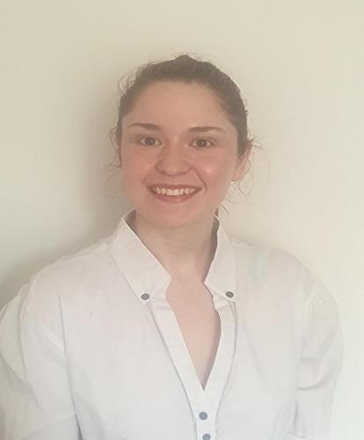  kaylakruger27@gmail.com  073 783 1491  ABOUT ME  I am a qualified EFL teacher with a Bachelor of Arts degree in Psychology and English. I enjoy making use of my qualifications to find a deeper level of understanding in my students, as well as using the skills taught to me in order to provide the best learning experience for my students. I am a team player and can work well with others.  HOBBIES  - Reading  - Writing poetry and short stories  - Karate  - Judo  PERSONAL DETAILS  DATE OF BIRTH: 2001/01/30  MARITAL STATUS: single  NATIONALITY: South African  DRIVING LICENCE: Yes  LANGUAGES SPOKEN: Afrikaans and English  REFEREES:  References may be provided upon request | Experience  - Provided judo classes at various primary schools (2022 - current):  I am required to create and implement my own lesson plans regarding the judo classes, as well as implement classroom management skills. I must provide lessons on specific material in a syllabus, as well as assess the competency of students regarding the material.  - My background in English allows me to provide clear and concise explanations during class.  - My background in psychology allows me to work well alongside others and communicate effectively with people of all ages and backgrounds.  - I have used the above skills with great success during my team teaching judo to young learners.  TEFL TRAINING  Level 5 168 Hour TEFL Certificate – The TEFL Academy, UK.  - March 2023 – August 2023  - Merit  - Developed lessons for various levels, including pre-intermediate, intermediate, and advanced ( and all levels in-between)  - Teaching speaking, listening, reading and writing  - Creation of materials and resources, and utilisation of the internet  - English grammar and how to teach the essential language  - Teaching in various situations and needs analysis.  - Techniques regarding teaching and classroom management  Education  Bachelor of Arts in Psychology and English  Eduvos  - Graduated Cum Laude in 2022  - Written and published short story in Poort 2018  - Member of Poetry club at Eduvos 2021 - 2022

EMPLOYMENT
- Provided judo classes at various primary schools: 2022 - current
- Created and implemented lesson plans, developed and used good classroom management skills, and taught relevant material to a class according to a syllabus.

