**Anine Lodewyk**

**T:** +27 73 738 3788

**E:** aninel18@gmail.com

**Address:**  Farm Mizpa, Hotazel, South Africa, 8490

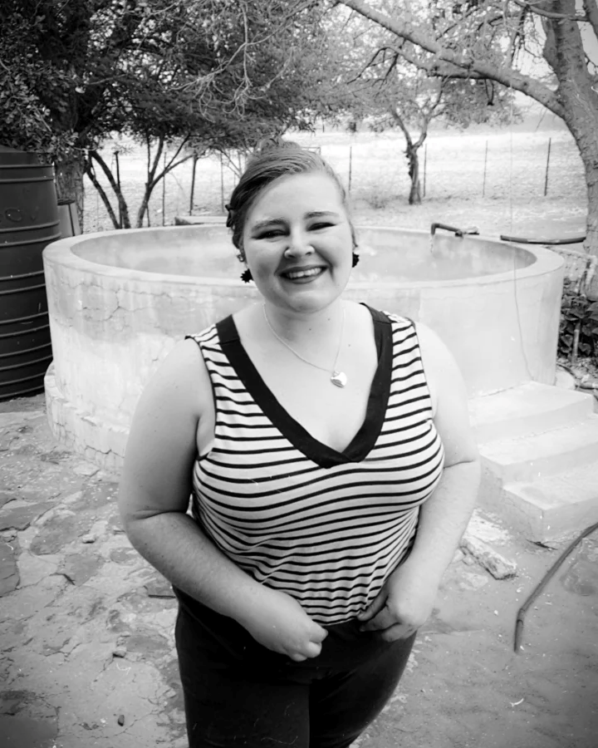**Profile**

I am a certified EFL teacher, a Grade C qualified security officer and I also have a matric certificate. I am a very creative person, and I am overly excited to be able to use this creativity in a classroom/online teaching environment. I communicate easily with anyone of any age, and I can work excellently in a team. I live on a farm, and I want to incorporate farm elements into my online lessons, and I believe that the students will learn easier when they have more fun and experience a lesson differently. But I will also ensure that a normal classroom setting is just as engaging by using videos and photos as my teaching aids.

**TEFL Qualifications**

**2023 Qualifi Level 5 Diploma in Teaching English as a Foreign Language (168 hours)** **- The TEFL Academy**

* I have a Ofqual regulated Level 5 qualification, and it is also DEAC approved.
* I have learned how to plan a lesson, how to manage a classroom, how to teach pronunciation and vocabulary to students, how to teach productive and receptive skills, how to teach grammar and how to develop materials that are suitable for face-to-face as well as online lessons.
* I learned how to teach A1 – C2 level students.

**Education & Courses**

2005 – 2010; 2012 - 2016 **Matric Certificate – Hotazel College**

- Grades 1 – 6: Afrikaans was my Home Language in these grades, and I had basic subjects such as Mathematics, Social Sciences, English First Additional Language, etc.

- Grades 8 – 12: In grades 8 and 9 I still had English as my First Additional, but I wanted to change to English Home Language. In grades 10, 11 & 12 I had English as my Home Language, as well as Visual Arts, Geography, Business studies and Afrikaans as my First Additional Language.

2007 **Grade 7 – Oranje-Noord Primary School**

- I changed schools for a year, but I went back to Hotazel College in Grade 8. I had basic school subjects, and I didn’t participate in any other after school activities.

**Relevant Experience**

My mother is a teacher, and she was my teacher as well when I was in Primary School. When I was older, my mother always asked me to help her grade some of her other student’s tests and mark their books. This is where my love for teaching started. I was the lead manager in 2016 with our school’s annual concert, I had to manage the other kids and make sure that everyone was in their place. I was a real teacher’s pet and I worked hard to keep my grades high. I was never a person for sport, but I was always present at the netball games, and I always helped on the athletics field.

**Employment**

2018 - 2019 **Cashier, OK Foods Bult, Potchefstroom**

* I handled money and I worked with clients.
* I worked long hours.

2019 - 2020 **Control room Operator, Mooirivier Beskerming, Potchefstroom**

* I worked dayshift as well as nightshifts, mostly 12-hour shifts.
* I dispatched reaction officers and handled alarms.
* I worked with clients, and I did some reception work over weekends.

2021 – 2023 **Control room Operator, CB Security North-West, Potchefstroom**

* I dispatched reaction officers and handled alarms.
* I worked dayshift as well as nightshifts, mostly 12-hour shifts.
* I monitored cctv cameras and reported any suspicious movements.

**Hobbies & Interests**

I have lambs that I take care of, and I love them so much. I had sick lambs and some of them turned around at death’s door. I also enjoy reading and cooking. I am not a very athletic person, but I keep in shape by running after my lambs. I also have other duties on the farm, and I enjoy being one with nature. I am also a game hunter, and I am currently working on a new vegetable garden. Music, movies, and swimming are only a few of my passions and I enjoy learning something new every day.

**Personal Details**

**Date of Birth:** 15th July 1998

**Nationality:** South African

**REFEREES ON REQUEST**