ILSE 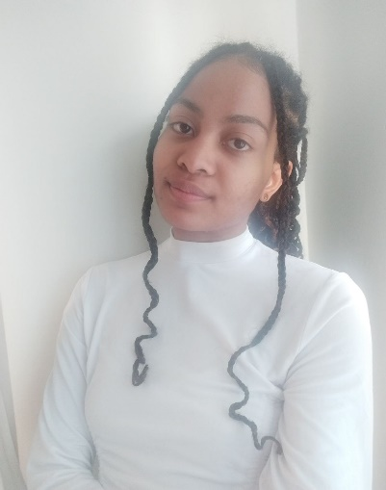

Biographics  - D.O.B – 07/09/1997  - Nationality – South African  - Languages – English  - Afrikaans  - Location – Western Province, Cape Town  - Gender – Female | Summary about myself  I am reserved but I come out of my shell once I am comfortable. I enjoy running, painting, hiking and various outdoor activities. I do find my energy in my alone time, needing to recharge with a good book.  I am originally from Cape Town, I moved up to Johannesburg work in August of 2021. I came back home in March 2023. I wish to start my career in my hometown, bringing back the multiple perspectives and experiences which I was able to gain in my time in the city of gold.  I am enthusiastic and curious when it comes to the things that interest me. A problem solver. A detail-oriented individual who enjoys marketing, finance and business administration. I believe there is power in diversity, and strength in numbers, it is better to work in a group and lighten the load as opposed to taking on every task on one’s own. I am an active listener, and I believe it aids me in being a leader or a team member, because we are all leaders in our own right.  I believe that I will bring a unique dynamic to your team.
Key Skills  - Driver’s license - yes  - Time management  - Organisational  - Communication  Contact details  PERSONAL EMAIL  Ilsemeyer98@gmail.com  CELLPHONE  +2771 801 8159 / +27 72 320 1188 | Experience  BRAND REPRESENTATIVE PUBLICIS COMMERCE  July-November 2023  - Present to grade 6 and 7 girls at various schools around the Western Cape  - Safekeeping of equipment necessary to set up the presentation at each school as well as stockkeeping.  - Complete monthly travel log and daily report submission.  FINANCE INTERNSHIP • HITACHI POWER GRIDS • 2021 – 2023  - Accounts receivables: Spearheaded this task and reduced overdues more than anyone else who had this role before me.  - VAT payables: Reduced and forged new methods to complete this task in the 18 months I have had at the company.  - Systems I used: SAP, Microsoft excel, Microsoft outlook.  - Facilitated project controlling through sales order creation  - Invoicing customers for orders received  Monthly Creditors Reconciliations as well as debtor’s reconciliations.  - Managed and maintained flow of sales order releases along with perfect timing order acknowledgements  LEARNERSHIP • MAERSK • 2020 – 2021  Fashion job numbers for cost and revenue totals: Worked in fast paced environment and always completed month end costings on time.  SYSEMS USED: Kewill accounting software  CALL CENTER STUDENT ASSSTANT • UWC • 2017 – 2018  Most calls answered within the 2-month period achievement  Core duties – regulate new application queries  CASHIER • EDGARS • 2016 – 2017  Core sales duties – manage customers at checkout, ensure customers are satisfied with service received  FLOOR ASSISTANT • PEP • 2015 – 2016  Cores sales duties – Unpack stock, accommodate customers: Excellent communication skills and customers enjoyed my service.  WAITRESS • SPUR • 2014 – 2015  - Core duties – Serve customers: knowing what customers wanted before they even ordered, that was strong customer service.  EDUCATION  HIGHER CERTIFICATE IN BUSINESS MANAGEMENT PRACTICES • 2023 • HENLEY BUSINESS SCHOOL  NQF 4 MARTKETING CERTIFICATE • 2022 • MAERSK  BCOM ACCOUNTING DEGREE • 2020 • UNIVERSITY OF THE WESTERN CAPE  Graduated 02 April 2020  REMOTE WORK FOUNDATIONS CERTIFICATION •2020 •GITLAB  SAGE PASTEL CERTIFICATE • 2018 • UWC  MATRIC CERTIFICATE • 2015 • SAREPTA SECONDARY SCHOOL  Grade 11&12 top achiever for Economics Involved in extra mural activities

VOLUNTEER / LEADERSHIP
  - Community clean-up projects such as IPYG Clean up
  - Paardeberg mountain retreat church camp councillor 2016-2019 (annual)
  - African Women chartered accountants
  - Women lead movement
  - Participation in vac work programmes at accounting firms
  - High School Prefect grade 12

