olivia roberts 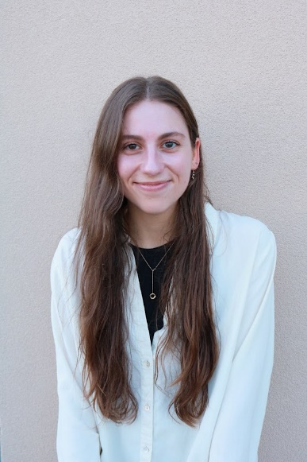
1630 Fairburn Dr. Cumming, GA 30040 | +1 (770) 335-4860 | oliviajoyroberts@gmail.com

personal details
Newly certified TEFL teacher seeking opportunities to teach beginner to advanced English learners.
Date of Birth: 6th April 1997
Marital Status: Single
Nationality: American (United States citizen)

tefl training
March 2022-May 2022 | Level 5 TEFL Certificate, 168 hours, The TEFL Academy, UK  Courses included:  - Creating materials and lessons for levels Elementary-Advanced  - Researching and creating materials and resources online  - Teaching speaking, listening, writing, and reading  - Analyzing various students’ needs  - Teaching techniques for different situations and classroom management  - Analyzing language (vocabulary, pronunciation, and grammar)

Experience
June 2021- Present | Self-employed Nanny/Caregiver  - Currently the primary childcare for a family while working on writing, language studies (Korean and French), and expanding my repertoire in cultural studies as well as receiving TEFL certification
April 2020- June 2021 | Lead Teacher, North Lanier Christian Academy  - Teaching at preschool for all levels from infant to four years old. Responsible for creating lesson plans, creating materials for class, teaching (speaking, writing, reading, pronunciation, vocabulary), and caring for children
November 2019- April 2020 | Customer Service Associate, Lowe’s  - Responsible for speaking with clients (mostly non-native English speakers), communicating with other departments, fulfilling orders, training for department transfers
September 2015- September 2017 | Customer Service Representative/Receptionist, Nationwide Insurance Agency  - Attentively dealt with clients, answered phones and client questions, provided customer support, managed office work, Microsoft Office, etc.

Skills & Abilities
Translation and language Research, editing
Computers and Microsoft Office Customer Service
Literature and Linguistics

Travel and Cultural Experience: Quebec, Canada (2021), Volunteer Intern (Scotland, 2019), Cross-cultural Intern (Belgium, 2019), England (2018), Study Abroad Program (France, 2016)
Languages: English (native), French (advanced-fluent), Korean (beginner-comprehensive)
Hobbies: Reading, writing, yoga, hiking, traveling, film and media, studying foreign languages (French and Korean)

