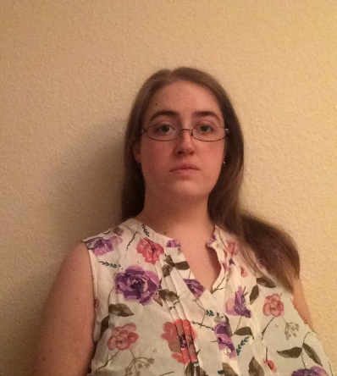**Victoria Jolliffe**

**E-mail:**  victoriajolliffe@yahoo.com

**Skype:** live:victoriajolliffe

**Address:** Flat 12, 4 Suffolk Drive, Gloucester, Gloucestershire, England, GL1 2AF.

**Telephone:** (+44) 07464113508

**Nationality:** British

**Date of birth:** 27th February 1990

**Education:**

**The TEFL Academy**

Level 5 TEFL Certificate 168-hours – April 2024 – Current

Including; Phonetics, Teaching Methodology, Classroom Management, Lesson Planning.

**TEFL Org UK**

TEFL Certificate 140-Hours - 2018-2019

Including; Grammar and Methodology courses, teaching large classes, telephone teaching course, teaching young learners.

TEFL advanced certificate – 30hr Teaching Young Learners – August 2021

**PTLLS (Preparing to Teach in the Lifelong Learning Sector)**

Level 4 certificate – 2014

Including; laws and legislations, resource and lesson planning.

**Morrisons Pharmacy**

Interact Pharmacy Assistant Course – 2016

Including; Mental Health, Protecting Children and Vulnerable Adults, Dementia Friends, Confidentiality, Data Protection, etc.

**Bournemouth University**

BSc (Hons) Heritage Conservation (2:2) – 2009-2012

Including; British archaeology, ecology and architecture.

**Weston College**

A-Levels (English Lang/Lit C, History E, Biology E) – 2007-2009

**Sir Harry Smith Community College**

12 GCSE’s, including English, Maths, History, German.

**Employment to date:**

**English Language Teacher –** Yothinburana Secondary School, Bangkok (2022 – April 2024).

I taught ‘English Reading and Writing’ and ‘English Listening and Speaking’ to 11–13-year-olds in a secondary school. The main aim of these classes is to practice and find everyday use for English grammar and phonetics. We covered a variety of topics including; poetry, storytelling, persuasive speeches, metaphors and similes, compound sentences and the correct paragraph form. I was responsible for designing and grading lesson plans, rubrics and exam papers.

**Pharmacy Assistant** - Morrisons Pharmacy, Weston-super-Mare (2015 - 2022).

My role requires me to use clear communication to interact with a wide variety of customers about potentially embarrassing subjects. This includes handling queries, prescriptions and providing medical and healthy living advice. I also assist in training new Pharmacy Assistants by shadowing them during everyday duties.

**Sales Assistant -** Morrisons Supermarket, Weston-super-Mare (Nov 2012 – 2022).

As a Sales Assistant I use my communication skills to provide good customer service.

**Learning Team Volunteer** - Weston-super-Mare Museum, Weston-super-Mare (2012 – 2017).

I worked as part of a team to design the Roman and Stone Age handling boxes for the Museums School outreach project. This included going into the local schools to deliver the handling box lessons.

**Useful Information:**

**Interests**: My passion for history and culture developed during my early childhood as a member of the Sealed Knot, an English Civil War re-enactment society. This has inspired a lot of my interests such as; researching folklore, writing, camping and archaeology. I also enjoy Tai Chi, anime and singing A cappella.

**Driving licence**: I hold a full driving licence.

**CRB/ ACRO**

**FAW:** (First Aid at Work) certificate (expired) – as a St John Cadet I learned practical first aid skills which can be renewed.

**Computer literacy**: Office, Word, PowerPoint, Publisher, Excel, Zoom and Microsoft Teams.

**Languages**: GCSE level German, HSK1 Mandarin and beginner level Thai.